**Maximize Your Knowledge Potential**

Smart, Secure, and Scalable Knowledge Management for Every Need

[Start now for Free](https://troweb.com/dashboard)

[Book a Meeting with us](https://troweb.zohobookings.com/#/troweb)

**Tailored Solutions to Meet Diverse Needs**



**Empower Your Personal Growth**

Effortlessly organize your research, learning materials, and personal projects. Access and manage your knowledge repository anytime, anywhere, and accelerate your personal and professional growth with intelligent insights.

* Customizable collections for personal projects.
* AI-powered search for quick access.
* OCR for seamless content extraction.

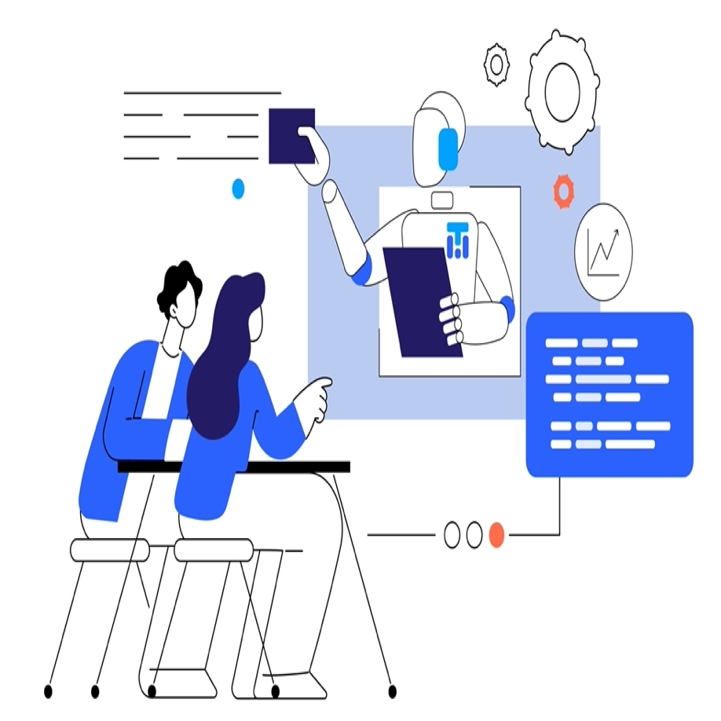

**Boost Team Collaboration and Productivity**

Eliminate information silos and streamline knowledge sharing across departments. Accelerate decision-making and enhance team collaboration with real-time, AI-powered insights.

* Collaborative document management.
* Secure access control.
* Instant AI-driven recommendations.



**Scale Knowledge Management Across Your Organization**

Implement a robust, secure, and compliant knowledge management system that grows with your enterprise. Transform your organizational knowledge into a strategic asset with advanced AI analytics.

* Enterprise-grade security and compliance.
* Hierarchical collections for complex organizations.
* Data-driven insights for informed decision-making.

**Embrace AI Swiftly**

A conversational AI platform for customer support, sales, and marketing

Top of Form

Start Chatting

Bottom of Form

What is troweb?

Tell me about its use cases.

How can troweb help me with my business?

Tell me about AI tutor.

Who can I talk to about my specialized needs?

**Want to hear more?**

Get news, tutorials and tips and offers about troweb. Enter your detail to subscribe!

Top of Form

Subscribe

No spam. You can unsubscribe at any time.

Bottom of Form

**Schedule a One-on-One Demo Meeting**

Experience a one-on-one meeting, see current solutions, get answers to your specific questions, and find out why troweb is the right choice for your enterprise.

[Schedule Demo](https://troweb.zohobookings.com/#/troweb)

# Empower Your Business with AI

On-site and Online Training Programs to Advance Your Team's AI Capabilities

[Schedule a Meeting](https://troweb.zohobookings.com/#/troweb)

[Learn More](https://www.troweb.com/enterprise)

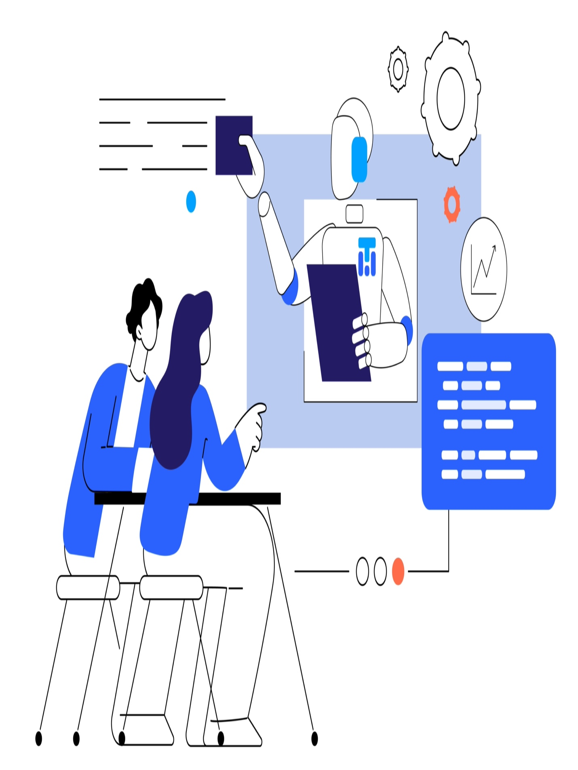

# Welcome to Our AI Academy

In a world increasingly driven by artificial intelligence, staying ahead requires knowledge and vision. Our AI Academy is dedicated to helping businesses like yours harness the transformative power of AI. By offering tailored training solutions for your team, we ensure that your organization is well-equipped to navigate the AI revolution and drive meaningful innovation.



## Why Choose Our AI Academy

Selecting the right training provider is crucial for your business's success in AI implementation. At troweb, our AI Academy stands out for its comprehensive curriculum, industry-expert trainers, and flexible learning modes. Here’s why we’re the preferred choice for businesses aiming to excel in AI:

### Comprehensive Curriculum

Our meticulously crafted curriculum covers a broad spectrum of AI applications, from the basics to advanced techniques. Whether it's understanding foundational concepts or exploring sophisticated AI algorithms, our courses are designed to address the specific needs of your business.

### Expert Trainers

Learn from the best in the industry. Our trainers are seasoned AI professionals with extensive experience in deploying AI solutions across various sectors. They bring real-world insights and practical knowledge to help your team effectively implement AI strategies.

### Flexible Learning Modes

We understand that every business operates differently. That's why we offer flexible training modes – choose on-site training for a more personal touch, or opt for online courses that can fit seamlessly into your team's busy schedule. Our goal is to make learning convenient and impactful for you.

## Our Training Programs

Our diverse range of AI training programs is designed to meet the needs of different roles within your organization. Whether you're a business leader looking to understand AI fundamentals, a data scientist seeking advanced skills, or a team aiming to implement AI strategies, we have courses tailored for you. Explore our offerings to find the perfect match for your team's needs and goals.



### AI Fundamentals for Business Leaders

Aimed at executives and decision-makers, this course covers the essential principles of AI, helping leaders make informed strategic decisions.

* Duration: 2 Days
* Mode:On-site/Online

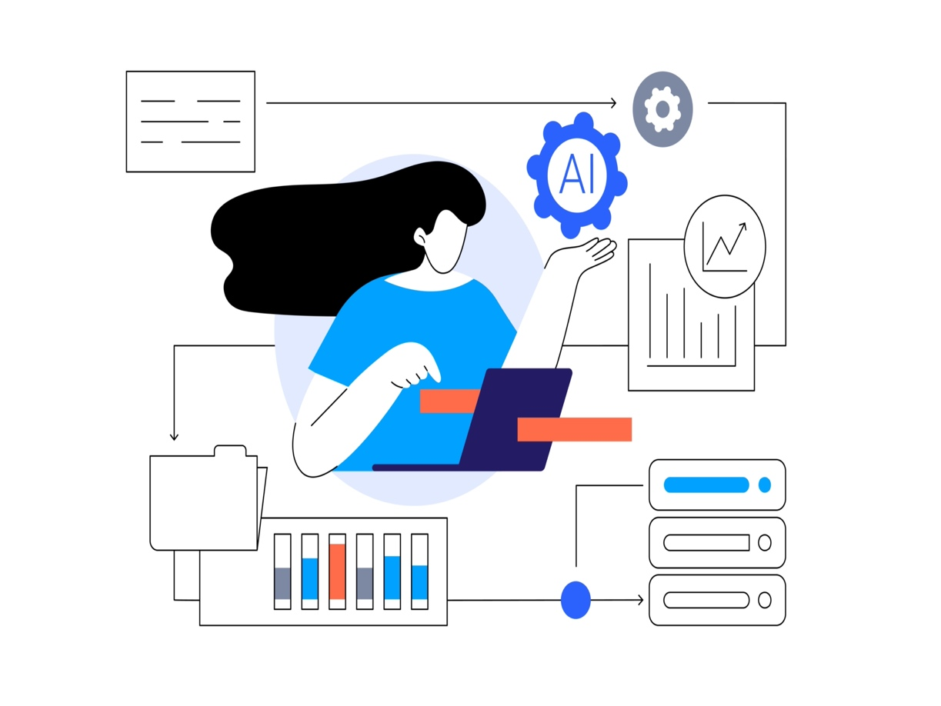

### Advanced AI for Data Scientists

Tailored for data science professionals, this course delves into advanced AI techniques, tools, and methodologies to elevate their technical prowess.

* Duration: 5 Days
* Mode:On-site/Online

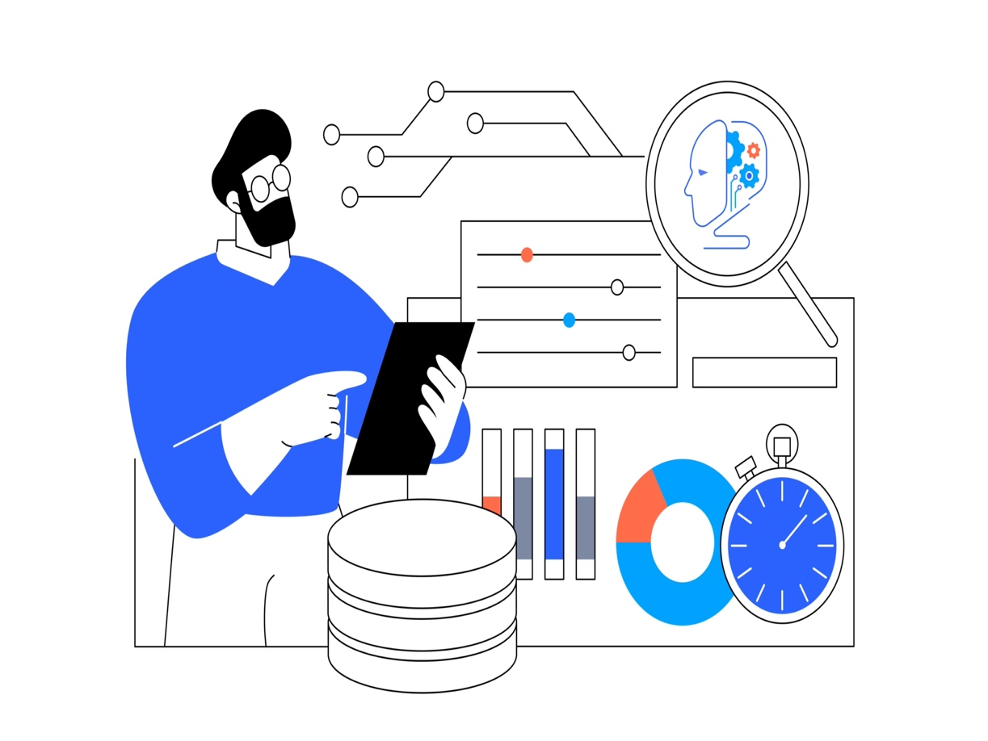

### AI Implementation Strategies

Focused on practical implementation, this course guides your team through the process of integrating AI technologies into your existing workflows and systems.

* Duration: 3 Days
* Mode: On-site/Online

# How Our Training Programs Work

At troweb AI Academy, our training programs are flexible and customized to meet your specific needs. From initial consultation to ongoing support, we ensure every step aligns with your business goals. Here’s how we make it happen:

**1**

#### Get in Touch

Reach out to us to discuss your needs and goals. Our team will help understand your business context and training needs. We ensure your team is well-prepared to utilize the knowledge gained effectively.

**2**

#### Customized Proposal

Based on your needs, we'll create a tailored training plan that aligns with your goals including course selection, scheduling, and delivery mode. We also keep your team updated with latest resources in AI.

**3**

#### Training Delivery

Our trainers will deliver the training on-site or online, ensuring an engaging and effective learning experience. We also provide follow-up assessments to reinforce learning outcomes.

**4**

#### Follow-up & Support

Post-training, we offer ongoing support to help your team apply their knowledge. Our experts are ready to assist with any challenges to ensure successful AI strategy implementation.

**Tailored AI Consulting for Your Enterprise**

At troweb, our AI consulting services are designed to transform your unique challenges into opportunities using the power of artificial intelligence. Partnering closely with your team, we provide the strategic insight and technical expertise needed to seamlessly integrate AI into your operations, driving innovation and efficiency.

[Schedule a Meeting](https://troweb.zohobookings.com/#/troweb)

[Checkout our Features](https://www.troweb.com/pricing)

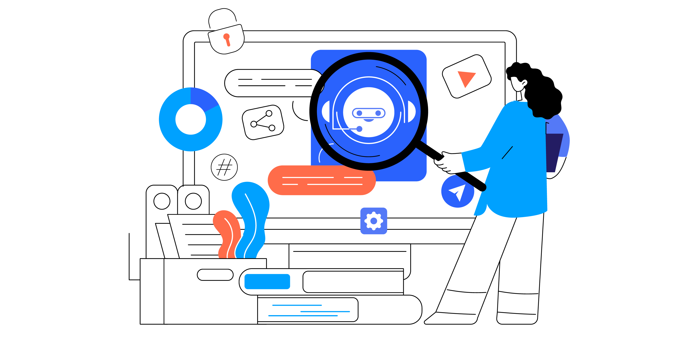

**Strategic AI Consulting Tailored to Your Needs**

Our consulting services go beyond traditional advice. We immerse ourselves in your organization to deliver actionable insights and customized AI solutions that align with your business goals.



**Comprehensive Analysis for Customized Strategies**

We begin by conducting a thorough analysis of your current operations, identifying areas where AI can deliver the most value. Our tailored strategies transform these insights into actionable plans, setting the foundation for successful AI integration.



**Collaborative AI Roadmapping**

Together, we develop a detailed AI adoption roadmap that aligns with your strategic objectives. This collaborative process ensures your team is part of the journey, fostering a culture ready for innovation and equipped to handle future growth.

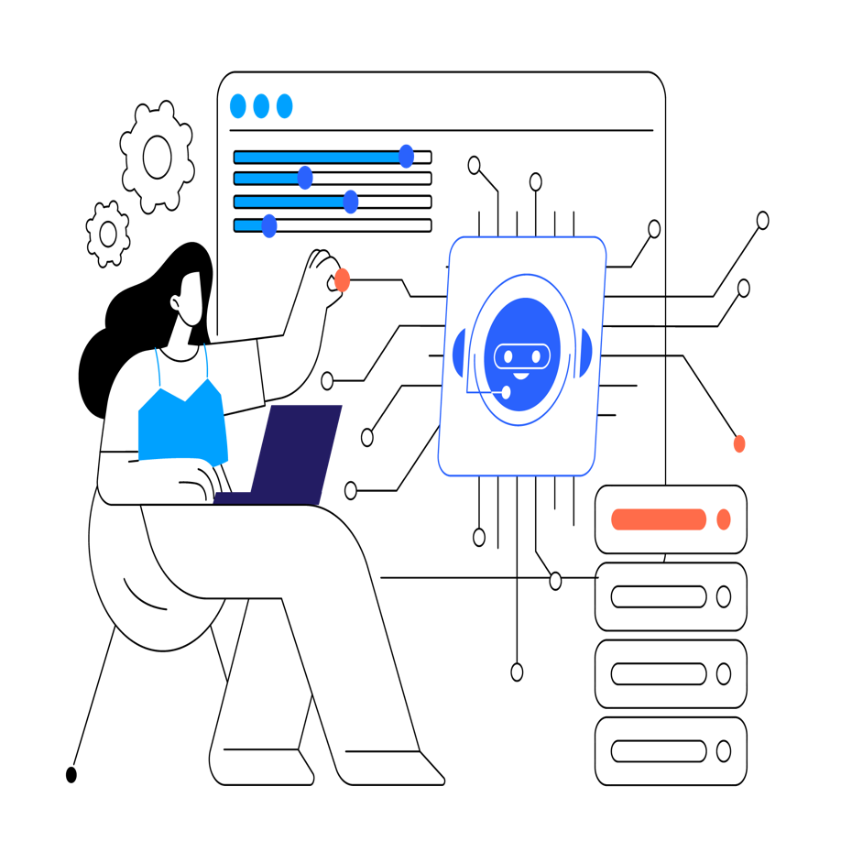

**Empowering Enterprises with AI Solutions**

At troweb, we empower enterprises with advanced AI solutions that drive meaningful transformation. Our comprehensive suite of AI capabilities enhances operational efficiency, improves decision-making, and streamlines workflows, enabling you to unlock the full potential of AI for your unique needs.



**Security and Data Governance**

Ensure data sovereignty, compliance, and the highest security standards with our AI solutions. At troweb, security and data governance are paramount. We offer data residency options, adhere to the highest security standards, and ensure compliance with relevant regulations. With our commitment to responsible AI, you can confidently unlock the full potential of AI for your organization.



**Tailored AI Models**

Our Tailored AI Models are crafted to address the unique challenges and objectives of each enterprise, providing customized solutions that align with specific business needs. By leveraging specialized AI models, we empower businesses to tackle complex problems, optimize processes, and drive innovation in their respective industries. Whether it's predictive analytics, natural language processing, or computer vision, our AI models are designed to deliver targeted, impactful solutions that cater to the distinct requirements of your organization. With a focus on precision and relevance, our specialized AI models are the cornerstone of driving meaningful transformation and competitive advantage for your enterprise.

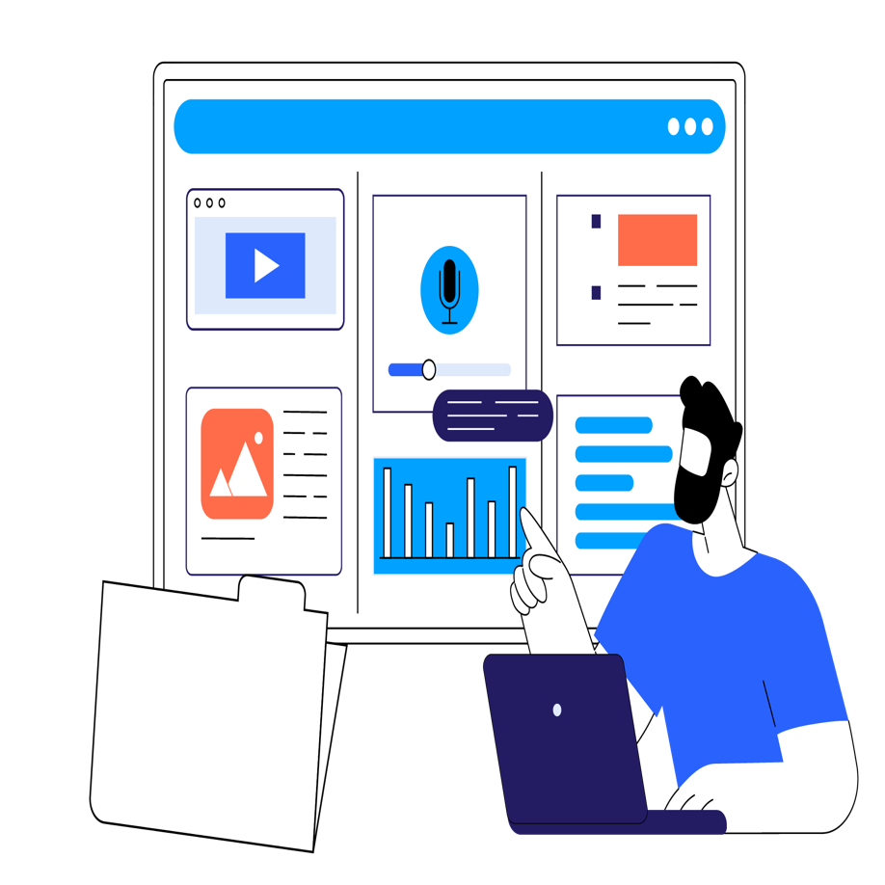

**Your Own Data Sources**

Our AI solutions are equipped to extract actionable insights from a wide array of data sources, including ERP systems, transactional databases, and data warehouses. Recognizing the value of diverse data sources, we enable businesses to harness the full potential of their data, facilitating informed decision-making and strategic planning. Whether structured or unstructured, our AI solutions are adept at processing and analyzing data from varied sources, providing a comprehensive view of your business landscape. By leveraging diverse data sources, our solutions empower enterprises to uncover valuable insights, identify trends, and drive informed, data-driven strategies that propel their organizations forward.

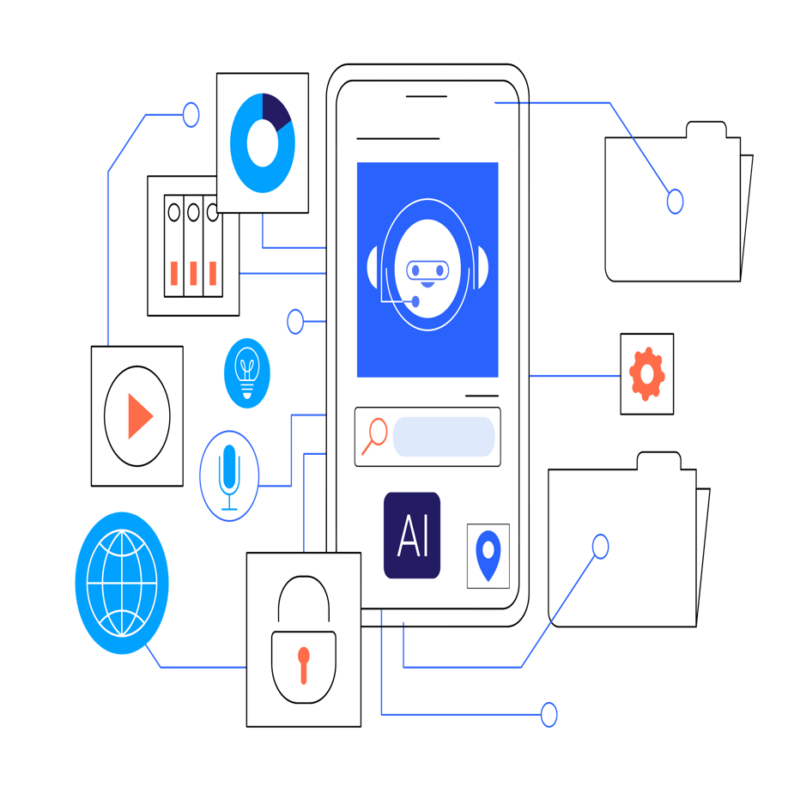

**AI End-to-End**

Our end-to-end AI solutions are meticulously designed to seamlessly integrate with your existing business processes, from data collection to actionable insights. Leveraging cutting-edge AI technologies, we empower enterprises to make smarter, data-driven decisions and drive operational excellence. Whether it's optimizing workflows, predicting customer behavior, or automating complex tasks, our AI solutions are tailored to enhance efficiency, productivity, and strategic decision-making. With a focus on real-world applications and tangible results, our end-to-end approach ensures that every aspect of your business can benefit from the transformative power of AI.



**Backoffice Automation**

Our Backoffice Automation solutions are designed to streamline workflows, enhance operational efficiency, and position enterprises at the forefront of technological advancement. By leveraging AI-driven automation, businesses can optimize routine tasks, reduce manual intervention, and improve overall productivity. From document processing to resource allocation, our solutions are tailored to automate repetitive back-office processes, allowing your team to focus on high-value activities and strategic initiatives. With a focus on driving efficiency and agility, our Backoffice Automation solutions empower organizations to adapt to evolving business demands, achieve cost savings, and stay competitive in today's dynamic marketplace.

**Under the Hood: Our AI Technology**

Explore the technical features that set us apart.

**Advanced Machine Learning**

Harness the power of advanced machine learning algorithms to analyze complex data patterns, predict outcomes, and optimize decision-making processes.

**Scalable Infrastructure**

Benefit from a scalable infrastructure that supports the seamless integration of AI solutions into your existing IT environment, ensuring flexibility and adaptability.

**Data Security Protocols**

Our AI solutions are fortified with advanced data security protocols, ensuring the protection of your organization's sensitive information against unauthorized access and cyber threats.

**Natural Language Processing (NLP)**

We analyze customer feedback, social media data, and other unstructured content to gain valuable insights into customer sentiment, preferences, and behavior.

**Predictive Modeling**

Utilize AI to forecast future outcomes, identify potential risks and opportunities, and make proactive decisions that drive your business forward.

**Real-time Data Analytics**

Analyzing data in real-time to identify trends, optimizing operations, and making informed decisions that respond to changing market conditions instantly.

# AI Tutor for Education

If you have your own rules for education, or have your customized framework, our AI based tutor can adapt to your asset repository and predefined framework.

[Schedule Demo](https://troweb.zohobookings.com/#/troweb)

# Why Do They Matter?

How customized AI agent is different from ChatGPT or similar products?

#### Your Own Approved Content

Instead of pool of unknown content out there in internet. A proper AI tutor should work withing boundaries of your own approved content.

#### Personalization

The AI conversational interface can have a closed loop of education with student and make personalization dream a reality

#### Add student record to context

Tutor is capable of reading context and information from back office systems to provide more accurate guidance to students

AI powered with a little help from you!

#### 1. point and import

Import your educational assets to the system

#### 2. Connect

Connect your back office systems to troweb

#### 3. Uplift your Students

Students will start to use system in personalized way

# Academic Repositories

Digital Academic Repositories are embracing AI in order to organize better, extract knowledge beyond original documents, and provide natural language and semantic interfaces for researchers.

[Schedule Meeting](https://troweb.zohobookings.com/#/troweb)

[Get Started for Free](https://www.troweb.com/dashboard)

Import from your current repository with a click or build it from scratch without needing to write a single line of code.

**Import It**

Import your existing repository and preserve years of work by your teams and academics.

**Build It**

Build it from scratch by just pointing at your contents and troweb creates relevant structures to store them.

**Enriched!**

OCR, speech to text, image and video analysis, and much more done to ago beyond raw documents.

**Search It**

With neural search and chat capabilities get deeper insight, or just do full text search.

AI powered with a little help from you!

#### 1. point and import

tell it where your contents areFaHandPointLeft

#### 2. organize and enrich

troweb organizes and finds hidden objects

#### 3. semantic search and chat

search as you talk

# Courseware Content Management

Let your MOOC or LMS course materials be stored in one place, organized, enriched, and made available in multiple channels, including your LMS.

[Schedule Meeting](https://troweb.zohobookings.com/#/troweb)

[Get Started for Free](https://www.troweb.com/dashboard)

troweb is a no code content management system which is easy and intuitive to use and is powered by AI.

**import, organize, enrich, store all types of assets**

**troweb AI discovers information hidden in assets**

**use them in courses or reuse in various channels**

AI powered with a little help from you!

#### 1. point and import

tell it where your contents are

#### 2. organize and enrich

troweb organizes and finds hidden objects

#### 3. semantic search and chat

search as you talk

# Artworks Collection for Artists

Artists, art galleries and art collectors are among those who can benefit immensely by managing their collections in troweb and offering an AI-powered interface for their works.

[Schedule Meeting](https://troweb.zohobookings.com/#/troweb)

[Get Started for Free](https://www.troweb.com/dashboard)

# Take a Trip to Art Land with Us

See for yourself how an artist has used troweb to build his collections of artwork in the past 6 decades and has provided smart access to it.



### Artist Details

Import artist details or add them one by one. Do not contain yourself to only artists whose works are added. With almost a click of a button you can ask troweb to harvest essential biography and history of artists.

* Get a directory of artists built for you
* Use AI tools to complete artists details
* Get deeper insights into an artist's world

### Add and Enrich Artworks

Artworks may be in different forms. Paintings, statues, artifacts, images, videos, performing art are among possibilities.

* Import artwork's digital form
* Enrich using troweb AI tools
* Enhance by adding personal curation

### Neural Search

troweb let's visitors use semantic search. In effect, it lets people search in their natural way of speaking. troweb understands what users are looking for and tries to come up with results in the artworks but also uses it general AI knowledge.

### Full Text Search

In some occasions full text search is what we need. With proper subject categorization and tagging, users are able to find what they need, exactly. Leave categorization and tagging to troweb AI engine. Do it manually if you are following a well established subject tree.

### Chat

We love to chat. Actually chat intelligently. Most chat widgets of products are turning to AI for meaningful interactions with users. Art world is one of the best areas that can be overhauled with intelligent chats. troweb chat is a continuation of its semantic search and deeper insight which allows users and visitors to art venues ask questions as if they are speaking.

AI powered with a little help from you!

#### 1. point and import

tell it where your contents are

#### 2. organize and enrich

troweb organizes and finds hidden objects

#### 3. semantic search and chat

search as you talk

**Transform Your Enterprise with Smooth Transition to AI Solutions**

Empower your enterprise with cutting-edge AI solutions tailored to your unique needs. Our comprehensive approach combines expert guidance, hands-on learning, and custom development to ensure a seamless integration of AI into your business processes. Partner with us to navigate the complexities of AI adoption and unlock new levels of efficiency, innovation, and competitive advantage for your enterprise.

[Schedule Meeting](https://troweb.zohobookings.com/#/troweb)

[Get Started Today](https://www.troweb.com/dashboard)

**What services we offer?**

Guiding your AI transformation. Tailoring solutions to your unique needs. Empowering your enterprise for the future.

**AI Academy**

Strategic training for your decision makers to get them on board with latest status and considerations of AI

**Consulting**

Our consulting team will investigate the DNA of your business and give you a tailored roadmap to embrace AI

**Cusomization**

Deliver customized solutions and applications to boost your business

**Embrace AI into Your Business**

A conversational AI platform for customer support, sales, and marketing

Top of Form

Start Chatting

Bottom of Form

What is troweb?

Tell me about its use cases.

How can troweb help me with my business?

Tell me about AI tutor.

Who can I talk to about my specialized needs?

**Empowering Enterprises with AI Solutions**

At troweb, we empower enterprises with advanced AI solutions that drive meaningful transformation. Our comprehensive suite of AI capabilities enhances operational efficiency, improves decision-making, and streamlines workflows, enabling you to unlock the full potential of AI for your unique needs.



**Training and Awareness**

Our AI Academy equips enterprise leaders and staff with essential knowledge to navigate the AI landscape. We cover fundamentals, opportunities, risks, and trends, enabling participants to assess AI readiness and develop integration strategies. Our balanced curriculum prepares both technical and business professionals to leverage AI responsibly and effectively, driving innovation while addressing challenges in the digital era.

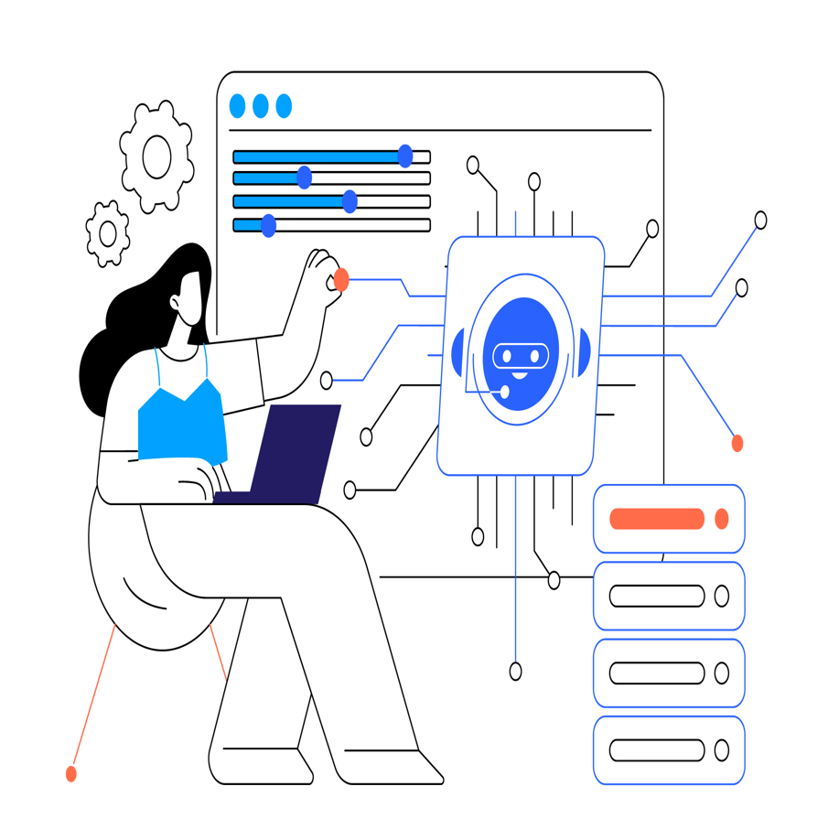

**Consulting**

Our AI consulting service delves into your organization's unique DNA, collaborating closely to understand your challenges and goals. We craft a customized AI adoption roadmap that aligns with your strategy, identifying key integration areas and potential hurdles. Our approach ensures AI adoption complements your workflows, driving innovation and efficiency while future-proofing your business in the AI era.

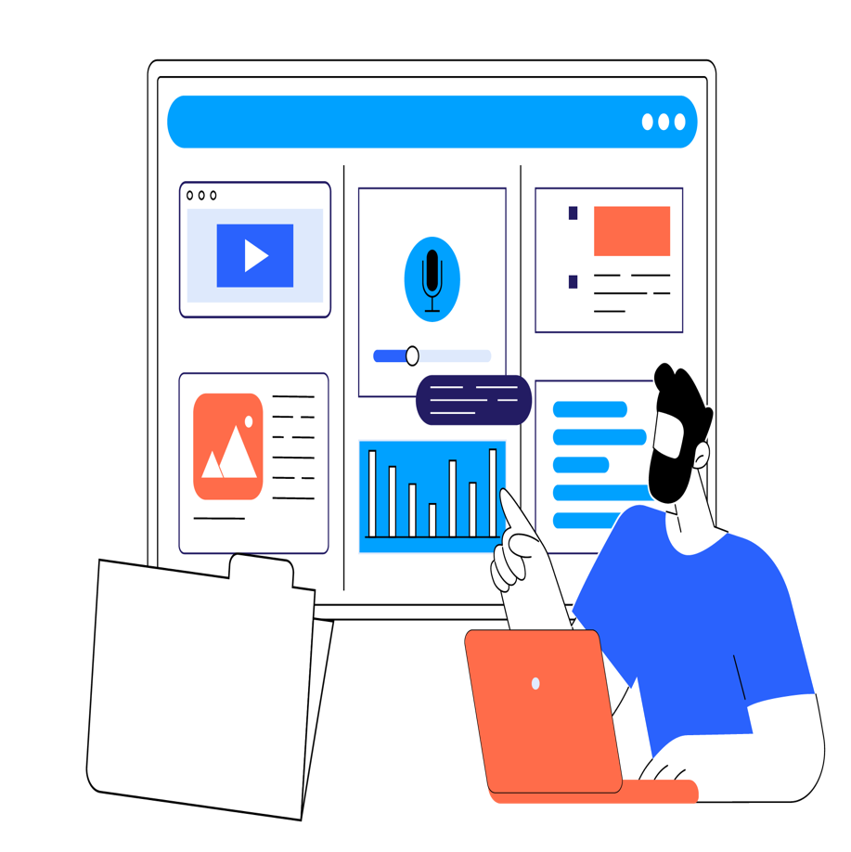

**Customization**

Our custom AI application development service creates tailor-made solutions for your specific needs. We identify high-impact areas and develop bespoke, seamlessly integrated applications using cutting-edge AI technologies. Our scalable, user-friendly solutions drive efficiency, automate processes, and unlock data insights, giving you a competitive edge to innovate faster and make data-driven decisions.

**Want to hear more?**

Get news, tutorials and tips and offers about troweb. Enter your detail to subscribe!

Top of Form

Subscribe

No spam. You can unsubscribe at any time.

Bottom of Form

**Schedule a One-on-One Demo Meeting**

Experience a one-on-one meeting, see current solutions, get answers to your specific questions, and find out why troweb is the right choice for your enterprise.

[Schedule Demo](https://troweb.zohobookings.com/#/troweb)

**Start for free. Pay as you grow. Switch at any time.**

No matter how many team members you have - our pricing is simple, transparent and adapts to the size of your company.

**Free**

**Free**

For individuals experimenting with troweb

* Ask AI about your content (GPT-4o Mini or similar model)
* Import and organize your content using AI
* AI Enabled Content Management System & Studio
* Modern API and Content Delivery Network

[Get Started For Free](https://www.troweb.com/dashboard/create)

**Pro**

**$449**

/month

For teams and small enterprises using troweb professionally

* Ask AI about your content (GPT-4o or similar models)
* Advanced importer with more content types
* Significantly increased resource qouta
* Modern API and Content Delivery Network

[Upgrade Now](https://www.troweb.com/dashboard)

**Enterprise**

**Custom**

For enterprises that want to supercharge their business using AI

* Ask AI analytical questions about your enterprise (GPT-4o or similar models)
* Custom resource & usage qoutas
* White label, custom branding and domain
* Uptime SLA, Dedicated Support, SSO, and SAML

[Contact Sales](https://troweb.zohobookings.com/#/troweb)

**Features**

**Breakdown of features**

**Free**

**Pro**

**Enterprise**

Import

**Import Text Documents**

Total number of AI imported text document pages (e.g. DocX, TXT, PDF)

5000

10000 / month

Custom

**Import Image Documents**

Total number of AI imported pages that need OCR to import (e.g. scanned PDF, etc)

2000

5000 / month

Custom

**Neural Search Index Size**

The total size of AI searchable text (An AI token consists of 4 characters on average)

10M tokens

25M tokens / month

Custom

Discover

**Chat Queries (per month)**

Number of monthly AI chat queries (each follow-up message is considered a new query)

600 (GPT-4o Mini or similar model)

5000 (GPT-4o or similar model)

Custom

**Similar Item Recommendations**

Get AI-driven suggestions for semantically similar content

**Faceted Search & Discovery**

Search & filter your content by their AI/user defined fields

**Blended Chat & Discovery Experience**

Smoothly transition between conversing with the AI and exploring items

**Analytical Queries**

Ask analytical questions that require performing calculation on a large body of content

**Actions Queries**

Ask AI to perform business related actions like sending emails, etc

**Conversational Mode**

Enables AI to ask for clarifications after each user query which generally results in better answers

**Custom GPTs**

Create OpenAI custom GPTs that uses your content to answer questions

Manage

**Content Management System**

AI Enabled CMS and Content Studio

**# Users**

Total number of users (regardless of their role) in each organization

3

20

∞

**Available Storage**

The total size of items and files stored in GB

10 GB

100 GB

Custom

**# Items**

The total number of items in an organization

10000

100000

Custom

**# Schemas**

The total number of schemas in an organization

20

100

Custom

**# Indexed Fields**

The total number of fields indexed for faceted search and filteration

200

1000

Custom

Deliver

**GraphQL API**

Deliver your content to various channels and audiences using the tailored API generated for your content

**Global Content Delivery Network**

Super fast delivery of your content to the your users across the global using our state of the art CDN

**CDN Bandwidth Usage (per month)**

Maximum amount of network bandwidth used by the organization users to get content

10 GB / month

75 GB / month

Custom

**CDN Requests Count (per month)**

Maximum number of network requests made by the organization users

100000 / month

1000000 / month

Custom

**Public Organizations**

Make your content publicly available to the world

**White Label**

Use your own name, logo and branding to deliver content to your users

**Custom Domain**

Use your own custom domain

**Single Sign On (SSO)**

Bring your own authentication provider by single-sign-on using OIDC and SAML

Support & Services

**AI Enabled Assistant**

Ask questions about our product and get instant answers using AI

**Community Forum**

Ask for help in our forum and become part of the troweb community

**Standard Support**

Access to our technical specialist team

**Response Time SLA**

Guaranteed support response times

**Uptime SLA**

Guaranteed 99.9% uptime

**24/7 Emergency Support**

Emergency support request 24/7, 365 days a year

Available

**Dedicated Support**

Thorough Customer Success Manager

Available

**Private Chat Channel**

Direct chat communication channel with the troweb team

Available

**Start for free. Test it. Talk to us for your ideal plan**

No matter how many team members you have, our pricing is simple, transparent and adapts to the size of your company.

# Privacy Policy of ****www.troweb.com****

Www.troweb.com collects some Personal Data from its Users.

Users may be subject to different protection standards and broader standards may therefore apply to some. Users can contact the Owner, to learn more about such standards.

This document can be printed for reference by using the print command in the settings of any browser.

## Owner and Data Controller

Troweb Soft  
Techno Hub, Silicon Oasis  
Dubai, UAE

**Owner contact email:** support@troweb.com

## Types of Data collected

Among the types of Personal Data that www.troweb.com collects, by itself or through third parties, there are: Trackers; Usage Data; first name; last name; email address; Data communicated while using the service; device information; password; username; company name; language; number of Users; session statistics.

Complete details on each type of Personal Data collected are provided in the dedicated sections of this privacy policy or by specific explanation texts displayed prior to the Data collection.  
Personal Data may be freely provided by the User, or, in case of Usage Data, collected automatically when using www.troweb.com.  
Unless specified otherwise, all Data requested by www.troweb.com is mandatory and failure to provide this Data may make it impossible for www.troweb.com to provide its services. In cases where www.troweb.com specifically states that some Data is not mandatory, Users are free not to communicate this Data without consequences to the availability or the functioning of the Service.  
Users who are uncertain about which Personal Data is mandatory are welcome to contact the Owner.  
Any use of Cookies – or of other tracking tools — by www.troweb.com or by the owners of third-party services used by www.troweb.com serves the purpose of providing the Service required by the User, in addition to any other purposes described in the present document and in the Cookie Policy.

Users are responsible for any third-party Personal Data obtained, published or shared through www.troweb.com.

## Mode and place of processing the Data

### Methods of processing

The Owner takes appropriate security measures to prevent unauthorized access, disclosure, modification, or unauthorized destruction of the Data.  
The Data processing is carried out using computers and/or IT enabled tools, following organizational procedures and modes strictly related to the purposes indicated. In addition to the Owner, in some cases, the Data may be accessible to certain types of persons in charge, involved with the operation of www.troweb.com (administration, sales, marketing, legal, system administration) or external parties (such as third-party technical service providers, mail carriers, hosting providers, IT companies, communications agencies) appointed, if necessary, as Data Processors by the Owner. The updated list of these parties may be requested from the Owner at any time.

### Place

The Data is processed at the Owner's operating offices and in any other places where the parties involved in the processing are located.  
  
Depending on the User's location, data transfers may involve transferring the User's Data to a country other than their own. To find out more about the place of processing of such transferred Data, Users can check the section containing details about the processing of Personal Data.

### Retention time

Unless specified otherwise in this document, Personal Data shall be processed and stored for as long as required by the purpose they have been collected for and may be retained for longer due to applicable legal obligation or based on the Users’ consent.

## The purposes of processing

The Data concerning the User is collected to allow the Owner to provide its Service, comply with its legal obligations, respond to enforcement requests, protect its rights and interests (or those of its Users or third parties), detect any malicious or fraudulent activity, as well as the following: Hosting and backend infrastructure, Analytics, Tag Management, Backup saving and management, Traffic optimization and distribution, Contacting the User, Handling payments, Access to third-party accounts, Registration and authentication, Registration and authentication provided directly by www.troweb.com and User database management.

For specific information about the Personal Data used for each purpose, the User may refer to the section “Detailed information on the processing of Personal Data”.

## Detailed information on the processing of Personal Data

Personal Data is collected for the following purposes and using the following services:

### Access to third-party accounts

### Analytics

### Backup saving and management

### Contacting the User

### Handling payments

### Hosting and backend infrastructure

### Registration and authentication

### Registration and authentication provided directly by www.troweb.com

### Tag Management

### Traffic optimization and distribution

### User database management

## Further information about the processing of Personal Data

### Selling goods and services online

## Cookie Policy

Www.troweb.com uses Trackers. To learn more, Users may consult the [Cookie Policy](https://www.iubenda.com/privacy-policy/77489025/cookie-policy).

## Further Information for Users in the European Union

This section applies to all Users in the European Union, according to the General Data Protection Regulation (the “GDPR”), and, for such Users, supersedes any other possibly divergent or conflicting information contained in the privacy policy. Further details regarding the categories of Data processed, the purposes of processing, the categories of recipients of the Personal Data, if any, and further information about Personal Data can be found in **the section titled “Detailed information on the processing of Personal Data” within this document**.

### Legal basis of processing

The Owner may process Personal Data relating to Users if one of the following applies:

* + - Users have given their consent for one or more specific purposes.
    - provision of Data is necessary for the performance of an agreement with the User and/or for any pre-contractual obligations thereof;
    - processing is necessary for compliance with a legal obligation to which the Owner is subject;
    - processing is related to a task that is carried out in the public interest or in the exercise of official authority vested in the Owner;
    - processing is necessary for the purposes of the legitimate interests pursued by the Owner or by a third party.

In any case, the Owner will gladly help to clarify the specific legal basis that applies to the processing, and in particular whether the provision of Personal Data is a statutory or contractual requirement, or a requirement necessary to enter into a contract.

### Further information about retention time

Unless specified otherwise in this document, Personal Data shall be processed and stored for as long as required by the purpose they have been collected for and may be retained for longer due to applicable legal obligation or based on the Users’ consent.

Therefore:

* + - Personal Data collected for purposes related to the performance of a contract between the Owner and the User shall be retained until such contract has been fully performed.
    - Personal Data collected for the purposes of the Owner’s legitimate interests shall be retained as long as needed to fulfill such purposes. Users may find specific information regarding the legitimate interests pursued by the Owner within the relevant sections of this document or by contacting the Owner.

The Owner may be allowed to retain Personal Data for a longer period whenever the User has given consent to such processing, as long as such consent is not withdrawn. Furthermore, the Owner may be obliged to retain Personal Data for a longer period whenever required to fulfil a legal obligation or upon order of an authority.  
  
Once the retention period expires, Personal Data shall be deleted. Therefore, the right of access, the right to erasure, the right to rectification and the right to data portability cannot be enforced after expiration of the retention period.

### The rights of Users based on the General Data Protection Regulation (GDPR)

Users may exercise certain rights regarding their Data processed by the Owner.

In particular, Users have the right to do the following, to the extent permitted by law:

* + - **Withdraw their consent at any time.** Users have the right to withdraw consent where they have previously given their consent to the processing of their Personal Data.
    - **Object to processing of their Data.** Users have the right to object to the processing of their Data if the processing is carried out on a legal basis other than consent.
    - **Access their Data.** Users have the right to learn if Data is being processed by the Owner, obtain disclosure regarding certain aspects of the processing and obtain a copy of the Data undergoing processing.
    - **Verify and seek rectification.** Users have the right to verify the accuracy of their Data and ask for it to be updated or corrected.
    - **Restrict the processing of their Data.** Users have the right to restrict the processing of their Data. In this case, the Owner will not process their Data for any purpose other than storing it.
    - **Have their Personal Data deleted or otherwise removed.** Users have the right to obtain the erasure of their Data from the Owner.
    - **Receive their Data and have it transferred to another controller.** Users have the right to receive their Data in a structured, commonly used and machine readable format and, if technically feasible, to have it transmitted to another controller without any hindrance.
    - **Lodge a complaint.** Users have the right to bring a claim before their competent data protection authority.

Users are also entitled to learn about the legal basis for Data transfers abroad including to any international organization governed by public international law or set up by two or more countries, such as the UN, and about the security measures taken by the Owner to safeguard their Data.

#### Details about the right to object to processing

**Where Personal Data is processed for a public interest, in the exercise of an official authority vested in the Owner or for the purposes of the legitimate interests pursued by the Owner, Users may object to such processing by providing a ground related to their particular situation to justify the objection.**

**Users must know that, however, should their Personal Data be processed for direct marketing purposes, they can object to that processing at any time, free of charge and without providing any justification. Where the User objects to processing for direct marketing purposes, the Personal Data will no longer be processed for such purposes. To learn whether the Owner is processing Personal Data for direct marketing purposes, Users may refer to the relevant sections of this document.**

#### How to exercise these rights

Any requests to exercise User rights can be directed to the Owner through the contact details provided in this document. Such requests are free of charge and will be answered by the Owner as early as possible and always within one month, providing Users with the information required by law. Any rectification or erasure of Personal Data or restriction of processing will be communicated by the Owner to each recipient, if any, to whom the Personal Data has been disclosed unless this proves impossible or involves disproportionate effort. At the Users’ request, the Owner will inform them about those recipients.

## Additional information about Data collection and processing

### Legal action

The User's Personal Data may be used for legal purposes by the Owner in Court or in the stages leading to possible legal action arising from improper use of www.troweb.com or the related Services.  
The User declares to be aware that the Owner may be required to reveal personal data upon request of public authorities.

### Additional information about User's Personal Data

In addition to the information contained in this privacy policy, www.troweb.com may provide the User with additional and contextual information concerning particular Services or the collection and processing of Personal Data upon request.

### System logs and maintenance

For operation and maintenance purposes, www.troweb.com and any third-party services may collect files that record interaction with www.troweb.com (System logs) or use other Personal Data (such as the IP Address) for this purpose.

### Information not contained in this policy

More details concerning the collection or processing of Personal Data may be requested from the Owner at any time. Please see the contact information at the beginning of this document.

### Changes to this privacy policy

The Owner reserves the right to make changes to this privacy policy at any time by notifying its Users on this page and possibly within www.troweb.com and/or - as far as technically and legally feasible - sending a notice to Users via any contact information available to the Owner. It is strongly recommended to check this page often, referring to the date of the last modification listed at the bottom.   
  
Should the changes affect processing activities performed on the basis of the User’s consent, the Owner shall collect new consent from the User, where required.

### Definitions and legal references

Latest update: May 01, 2024

[iubenda](https://www.iubenda.com/en/privacy-and-cookie-policy-generator) hosts this content and only collects [the Personal Data strictly necessary](https://www.iubenda.com/privacy-policy/65675001) for it to be provided.

## Cookie Policy of www.troweb.com

This document informs Users about the technologies that help www.troweb.com to achieve the purposes described below. Such technologies allow the Owner to access and store information (for example by using a Cookie) or use resources (for example by running a script) on a User’s device as they interact with www.troweb.com.

For simplicity, all such technologies are defined as "Trackers" within this document – unless there is a reason to differentiate.  
For example, while Cookies can be used on both web and mobile browsers, it would be inaccurate to talk about Cookies in the context of mobile apps as they are a browser-based Tracker. For this reason, within this document, the term Cookies is only used where it is specifically meant to indicate that particular type of Tracker.

Some of the purposes for which Trackers are used may also require the User's consent, depending on the applicable law. Whenever consent is given, it can be freely withdrawn at any time following the instructions provided in this document.

Www.troweb.com uses Trackers managed directly by the Owner (so-called “first-party” Trackers) and Trackers that enable services provided by a third-party (so-called “third-party” Trackers). Unless otherwise specified within this document, third-party providers may access the Trackers managed by them.  
The validity and expiration periods of Cookies and other similar Trackers may vary depending on the lifetime set by the Owner or the relevant provider. Some of them expire upon termination of the User’s browsing session.  
In addition to what’s specified in the descriptions within each of the categories below, Users may find more precise and updated information regarding lifetime specification as well as any other relevant information — such as the presence of other Trackers — in the linked privacy policies of the respective third-party providers or by contacting the Owner.

### Activities strictly necessary for the operation of www.troweb.com and delivery of the Service

Www.troweb.com uses so-called “technical” Cookies and other similar Trackers to carry out activities that are strictly necessary for the operation or delivery of the Service.

### Other activities involving the use of Trackers

#### Functionality

Www.troweb.com uses Trackers to enable basic interactions and functionalities, allowing Users to access selected features of the Service and facilitating the User's communication with the Owner.

### Registration and authentication

#### Experience

Www.troweb.com uses Trackers to improve the quality of the user experience and enable interactions with external content, networks and platforms.

### Access to third-party accounts

#### Measurement

Www.troweb.com uses Trackers to measure traffic and analyse User behaviour to improve the Service.

### Analytics

### Anonymized analytics services

### How to manage preferences and provide or withdraw consent on www.troweb.com

Whenever the use of Trackers is based on consent, users can provide or withdraw such consent by setting or updating their preferences via the relevant privacy choices panel available on www.troweb.com.

With regard to any third-party Trackers, Users can manage their preferences via the related opt-out link (where provided), by using the means indicated in the third party's privacy policy, or by contacting the third party.

#### How to control or delete Cookies and similar technologies via your device settings

Users may use their own browser settings to:

* + - * See what Cookies or other similar technologies have been set on the device;
      * Block Cookies or similar technologies;
      * Clear Cookies or similar technologies from the browser.

The browser settings, however, do not allow granular control of consent by category.

Users can, for example, find information about how to manage Cookies in the most commonly used browsers at the following addresses:

* + - * [Google Chrome](https://support.google.com/chrome/answer/95647?hl=en&p=cpn_cookies)
      * [Mozilla Firefox](https://support.mozilla.org/en-US/kb/enable-and-disable-cookies-website-preferences)
      * [Apple Safari](https://support.apple.com/guide/safari/manage-cookies-and-website-data-sfri11471/)
      * [Microsoft Internet Explorer](http://windows.microsoft.com/en-us/windows-vista/block-or-allow-cookies)
      * [Microsoft Edge](https://support.microsoft.com/en-us/help/4027947)
      * [Brave](https://support.brave.com/hc/en-us/articles/360022806212-How-do-I-use-Shields-while-browsing)
      * [Opera](https://help.opera.com/en/latest/web-preferences/#cookies)

Users may also manage certain categories of Trackers used on mobile apps by opting out through relevant device settings such as the device advertising settings for mobile devices, or tracking settings in general (Users may open the device settings and look for the relevant setting).

#### Consequences of denying the use of Trackers

Users are free to decide whether or not to allow the use of Trackers. However, please note that Trackers help www.troweb.com to provide a better experience and advanced functionalities to Users (in line with the purposes outlined in this document). Therefore, if the User chooses to block the use of Trackers, the Owner may be unable to provide related features.

### Owner and Data Controller

Troweb Soft  
Techno Hub, Silicon Oasis  
Dubai, UAE

**Owner contact email:** support@troweb.com

Since the use of third-party Trackers through www.troweb.com cannot be fully controlled by the Owner, any specific references to third-party Trackers are to be considered indicative. In order to obtain complete information, Users are kindly requested to consult the privacy policies of the respective third-party services listed in this document.

Given the objective complexity surrounding tracking technologies, Users are encouraged to contact the Owner should they wish to receive any further information on the use of such technologies by www.troweb.com.

### Definitions and legal references

Latest update: May 01, 2024

[iubenda](https://www.iubenda.com/en/cookie-solution) hosts this content and only collects [the Personal Data strictly necessary](https://www.iubenda.com/privacy-policy/65675001) for it to be provided.

[Show the complete Privacy Policy](https://www.iubenda.com/privacy-policy/77489025/legal?from_cookie_policy=true)

# Terms and Conditions of ****www.troweb.com****

These Terms govern

* the use of www.troweb.com, and,
* any other related Agreement or legal relationship with the Owner

in a legally binding way. Capitalized words are defined in the relevant dedicated section of this document.

The User must read this document carefully.

Www.troweb.com is provided by:

Troweb Soft  
Techno Hub, Silicon Oasis  
Dubai, UAE

**Owner contact email:** support@troweb.com

"Www.troweb.com" refers to

* this website, including its subdomains and any other website through which the Owner makes its Service available;
* applications for mobile, tablet and other smart device systems;
* the Application Program Interfaces (API);

## What the User should know at a glance

* Please note that some provisions in these Terms may only apply to certain categories of Users. In particular, certain provisions may only apply to Consumers or to those Users that do not qualify as Consumers. Such limitations are always explicitly mentioned within each affected clause. In the absence of any such mention, clauses apply to all Users.
* **Usage of www.troweb.com and the Service is age restricted**: to access and use www.troweb.com and its Service the User must be an adult under applicable law.
* The right of withdrawal only applies to European Consumers.
* Www.troweb.com uses automatic renewal for Product subscriptions. Information about the a) renewal period, b) termination details and c) termination notice can be found in the relevant section of these Terms.
* Important: Consumers based in Germany have different rules applying to them as described in the relevant section of these Terms.

## TERMS OF USE

Unless otherwise specified, the terms of use detailed in this section apply generally when using www.troweb.com.

Single or additional conditions of use or access may apply in specific scenarios and in such cases are additionally indicated within this document.

By using www.troweb.com, Users confirm to meet the following requirements:

* There are no restrictions for Users in terms of being Consumers or Business Users;
* Users must be recognized as adult by applicable law;
* Users aren’t located in a country that is subject to a U.S. Government embargo, or that has been designated by the U.S. Government as a “terrorist-supporting” country;
* Users aren’t listed on any U.S. Government list of prohibited or restricted parties;

### Account registration

To use the Service Users must register or create a User account, providing all required data or information in a complete and truthful manner.  
Failure to do so will cause unavailability of the Service.

Users are responsible for keeping their login credentials confidential and safe. For this reason, Users are also required to choose passwords that meet the highest standards of strength permitted by www.troweb.com.

By registering, Users agree to be fully responsible for all activities that occur under their username and password.  
Users are required to immediately and unambiguously inform the Owner via the contact details indicated in this document, if they think their personal information, including but not limited to User accounts, access credentials or personal data, have been violated, unduly disclosed or stolen.

#### Account termination

Users can terminate their account and stop using the Service at any time by doing the following:

* By directly contacting the Owner at the contact details provided in this document.

#### Account suspension and deletion

The Owner reserves the right, at its sole discretion, to suspend or delete at any time and without notice, User accounts that it deems inappropriate, offensive or in violation of these Terms.

The suspension or deletion of User accounts shall not entitle Users to any claims for compensation, damages or reimbursement.

The suspension or deletion of accounts due to causes attributable to the User does not exempt the User from paying any applicable fees or prices.

### Content on www.troweb.com

Unless where otherwise specified or clearly recognizable, all content available on www.troweb.com is owned or provided by the Owner or its licensors.

The Owner undertakes its utmost effort to ensure that the content provided on www.troweb.com infringes no applicable legal provisions or third-party rights. However, it may not always be possible to achieve such a result.  
In such cases, without prejudice to any legal prerogatives of Users to enforce their rights, Users are kindly asked to preferably report related complaints using the contact details provided in this document.

#### Rights regarding content on www.troweb.com - All rights reserved

The Owner holds and reserves all intellectual property rights for any such content.

Users may not, therefore, use such content in any way that is not necessary or implicit in the proper use of the Service.

In particular, but without limitation, Users may not copy, download, share (beyond the limits set forth below), modify, translate, transform, publish, transmit, sell, sublicense, edit, transfer/assign to third parties or create derivative works from the content available on www.troweb.com, nor allow any third party to do so through the User or their device, even without the User's knowledge.

Where explicitly stated on www.troweb.com, the User may download, copy and/or share some content available through www.troweb.com for its sole personal and non-commercial use and provided that the copyright attributions and all the other attributions requested by the Owner are correctly implemented.

Any applicable statutory limitation or exception to copyright shall stay unaffected.

### Content provided by Users

The Owner allows Users to upload, share or provide their own content to www.troweb.com.

By providing content to www.troweb.com, Users confirm that they are legally allowed to do so and that they are not infringing any statutory provisions and/or third-party rights.

#### Rights regarding content provided by Users

Users acknowledge and accept that by providing their own content on www.troweb.com they grant the Owner a non-exclusive, fully paid-up and royalty-free license to process such content solely for the operation and maintenance of www.troweb.com as contractually required.

To the extent permitted by applicable law, Users waive any moral rights in connection with content they provide to www.troweb.com.

Users acknowledge, accept and confirm that all content they provide through www.troweb.com is provided subject to the same general conditions set forth for content on www.troweb.com.

#### Liability for provided content

Users are solely liable for any content they upload, post, share, or provide through www.troweb.com. Users acknowledge and accept that **the Owner does not filter or moderate such content**.

However, the Owner reserves the right to remove, delete or block such content at its own discretion and, without prior notice, to deny the uploading User access to www.troweb.com:

* upon becoming aware of any (alleged) violation of these Terms, any third-party rights, or applicable law, based on such content;
* if a notice of infringement of intellectual property rights is received;
* if a notice of violation of a third party’s privacy, including their intimate privacy, is received;
* upon order of a public authority; or
* where the Owner is made aware that the content, while being accessible via www.troweb.com, may represent a risk for Users, third parties and/or the availability of the Service.

The removal, deletion or blocking of content shall not entitle Users that have provided such content or that are liable for it, to any claims for compensation, damages or reimbursement.

Users agree to hold the Owner harmless from and against any claim asserted and/or damage suffered due to content they provided to or provided through www.troweb.com.

#### Access to provided content

Content that Users provide to www.troweb.com is made available according to the criteria outlined within this section.

##### Publicly available content

Content meant for public availability shall be automatically made public on www.troweb.com upon upload or, at the sole discretion of the Owner, at a later stage.

Any personal data, identifier or any other information that Users upload in connection with such content (such as a User-ID, avatar or nickname etc.) shall also appear in connection with the published content.

##### Private content

Private content provided by Users shall stay private and will not be shared with any third parties or accessed by the Owner without the User’s explicit consent.

Users may (and are encouraged to) check on www.troweb.com to find details of who can access the content they provide.

### Access to external resources

Through www.troweb.com Users may have access to external resources provided by third parties. Users acknowledge and accept that the Owner has no control over such resources and is therefore not responsible for their content and availability.

Conditions applicable to any resources provided by third parties, including those applicable to any possible grant of rights in content, result from each such third parties’ terms and conditions or, in the absence of those, applicable statutory law.

### How to file a takedown notice (called a “DMCA notice”)

If copyright holders or their agents believe that any content on www.troweb.com infringes upon their copyrights, they may submit a notification pursuant to the Digital Millennium Copyright Act ("DMCA") by providing the Owner’s Copyright Agent with the following information in writing (see 17 U.S.C 512(c)(3) for further detail):

* A physical or electronic signature of a person authorized to act on behalf of the holder of an exclusive right that is allegedly infringed;
* Identification of the copyrighted work claimed to have been infringed, or, if multiple copyrighted works at a single online site are covered by a single notification, a representative list of such works at that site;
* Identification of the material that is claimed to be infringing or to be the subject of infringing activity and that is to be removed or access to which is to be disabled and information reasonably sufficient to permit the Owner to locate the material;
* Information reasonably sufficient to permit the Owner to contact the notifying party, such as an address, telephone number, and, if available, an electronic mail;
* A statement that the notifying party has a good faith belief that use of the material in the manner complained of is not authorized by the copyright owner, its agent, or the law; and
* A statement that the information in the notification is accurate, and under penalty of perjury, that the notifying party is authorized to act on behalf of the owner of an exclusive right that is allegedly infringed.

Failure to comply with all of the requirements outlined above may result in invalidity of the DMCA notice.

Copyright infringement notifications may be addressed to the Owner’s Copyright Agent at the contact details specified in this document.

### Acceptable use

Www.troweb.com and the Service may only be used within the scope of what they are provided for, under these Terms and applicable law.

Users are solely responsible for making sure that their use of www.troweb.com and/or the Service violates no applicable law, regulations or third-party rights.

Therefore, **the Owner reserves the right to take any appropriate measure to protect its legitimate interests including by denying Users access to www.troweb.com or the Service, terminating contracts, reporting any misconduct performed through www.troweb.com or the Service to the competent authorities – such as judicial or administrative authorities - whenever Users engage or are suspected to engage in any of the following activities:**

* violate laws, regulations and/or these Terms;
* infringe any third-party rights;
* considerably impair the Owner’s legitimate interests;
* offend the Owner or any third party.

### Software license

Any intellectual or industrial property rights, and any other exclusive rights on software or technical applications embedded in or related to www.troweb.com are held by the Owner and/or its licensors.

Subject to Users’ compliance with and notwithstanding any divergent provision of these Terms, the Owner merely grants Users a revocable, non-exclusive, non-sublicensable and non-transferable license to use the software and/or any other technical means embedded in the Service within the scope and for the purposes of www.troweb.com and the Service offered.

This license does not grant Users any rights to access, usage or disclosure of the original source code. All techniques, algorithms, and procedures contained in the software and any documentation thereto related is the Owner’s or its licensors’ sole property.

All rights and license grants to Users shall immediately terminate upon any termination or expiration of the Agreement.

### API usage terms

Users may access their data relating to www.troweb.com via the Application Program Interface (API). Any use of the API, including use of the API through a third-party product/service that accesses www.troweb.com, is bound by these Terms and, in addition, by the following specific terms:

* the User expressly understands and agrees that the Owner bears no responsibility and shall not be held liable for any damages or losses resulting from the User’s use of the API or their use of any third-party products/services that access data through the API.

## TERMS AND CONDITIONS OF SALE

### Provision of personal data

To access or receive some of the Products provided via www.troweb.com as part of the Service, Users may be required to provide their personal data as indicated on www.troweb.com.

### Paid Products

Some of the Products provided on www.troweb.com, as part of the Service, are provided on the basis of payment.

The fees, duration and conditions applicable to the purchase of such Products are described below and in the dedicated sections of www.troweb.com.

To purchase Products, the User must register or log into www.troweb.com.

### Product description

Prices, descriptions or availability of Products are outlined in the respective sections of www.troweb.com and are subject to change without notice.

While Products on www.troweb.com are presented with the greatest accuracy technically possible, representation on www.troweb.com through any means (including, as the case may be, graphic material, images, colors, sounds) is for reference only and implies no warranty as to the characteristics of the purchased Product.

The characteristics of the chosen Product will be outlined during the purchasing process.

### Purchasing process

Any steps taken from choosing a Product to order submission form part of the purchasing process.

The purchasing process includes these steps:

* Users must choose the desired Product and verify their purchase selection.
* After having reviewed the information displayed in the purchase selection, Users may place the order by submitting it.

### Order submission

When the User submits an order, the following applies:

* The submission of an order determines contract conclusion and therefore creates for the User the obligation to pay the price, taxes and possible further fees and expenses, as specified on the order page.
* In case the purchased Product requires an action from the User, such as the provision of personal information or data, specifications or special wishes, the order submission creates an obligation for the User to cooperate accordingly.
* Upon submission of the order, Users will receive a receipt confirming that the order has been received.

All notifications related to the described purchasing process shall be sent to the email address provided by the User for such purposes.

### Prices

Users are informed during the purchasing process and before order submission, about any fees, taxes and costs (including, if any, delivery costs) that they will be charged.

Prices on www.troweb.com are displayed:

* excluding any applicable fees, taxes and costs.

### Offers and discounts

The Owner may offer discounts or provide special offers for the purchase of Products. Any such offer or discount shall always be subject to the eligibility criteria and the terms and conditions set out in the corresponding section of www.troweb.com.

Offers and discounts are always granted at the Owner’s sole discretion.

Repeated or recurring offers or discounts create no claim/title or right that Users may enforce in the future.

Depending on the case, discounts or offers shall be valid for a limited time only or while stocks last. If an offer or discount is limited by time, the time indications refer to the time zone of the Owner, as indicated in the Owner’s location details in this document, unless otherwise specified.

### Methods of payment

Information related to accepted payment methods is made available during the purchasing process.

Some payment methods may only be available subject to additional conditions or fees. In such cases related information can be found in the dedicated section of www.troweb.com.

All payments are independently processed through third-party services. Therefore, www.troweb.com does not collect any payment information – such as credit card details – but only receives a notification once the payment has been successfully completed. The User may read the privacy policy of www.troweb.com to learn more about the data processing and Users’ rights regarding their data.

If a payment through the available methods fails or is refused by the payment service provider, the Owner shall be under no obligation to fulfill the purchase order. If a payment fails or is refused, the Owner reserves the right to claim any related expenses or damages from the User.

### Retention of usage rights

Users do not acquire any rights to use the purchased Product until the total purchase price is received by the Owner.

### Delivery

#### Performance of services

The purchased service shall be performed or made available within the timeframe specified on www.troweb.com or as communicated before the order submission.

### Contract duration

#### Trial period

Users have the option to test www.troweb.com or selected Products during a limited and non-renewable trial period, at no cost. Some features or functions of www.troweb.com may not be available to Users during the trial period.  
Further conditions applicable to the trial period, including its duration, will be specified on www.troweb.com.

The trial period shall end automatically and shall not convert into any paid Product unless the User actively purchases such paid Product.

#### Subscriptions

Subscriptions allow Users to receive a Product continuously or regularly over time. Details regarding the type of subscription and termination are outlined below.

#### Fixed-term subscriptions

Paid fixed-term subscriptions start on the day the payment is received by the Owner and last for the subscription period chosen by the User or otherwise specified during the purchasing process.

Once the subscription period expires, the Product shall no longer be accessible.

#### Automatic renewal of fixed-term subscriptions

**Subscriptions are automatically renewed through the payment method that the User chose during purchase.**

**The renewed subscription will last for a period equal to the original term.**

The User shall receive a reminder of the upcoming renewal with reasonable advance, outlining the procedure to be followed in order to cancel the automatic renewal.

##### Termination

**Subscriptions may be terminated by sending a clear and unambiguous termination notice to the Owner using the contact details provided in this document, or — if applicable — by using the corresponding controls inside www.troweb.com.**

**If the notice of termination is received by the Owner before the subscription renews, the termination shall take effect as soon as the current period is completed.**

#### Exception for Consumers based in Germany

However, regardless of the above, if the User is based in Germany and qualifies as a Consumer, the following applies:

**At the end of the initial term, subscriptions are automatically extended for an unlimited period, unless the User terminates before the end of such term.**

**The fee due upon extension will be charged on the payment method that the User chose during purchase.**

**After extension, the subscription will last for an indefinite period and may be terminated monthly.**

The User shall receive a reminder of the upcoming unlimited extension with reasonable advance, outlining the procedure to be followed in order to prevent the extension or terminate the subscription thereafter.

##### Termination

**Extended subscriptions may be terminated at any time by sending a clear and unambiguous termination notice to the Owner using the contact details provided in this document, or — if applicable — by using the corresponding controls inside www.troweb.com.**

**If the notice of termination is received by the Owner by the end of the current month, the subscription shall expire at the end of such month.**

## User rights

### Right of withdrawal

Unless exceptions apply, the User may be eligible to withdraw from the contract within the period specified below (generally 14 days), for any reason and without justification. Users can learn more about the withdrawal conditions within this section.

#### Who the right of withdrawal applies to

Unless any applicable exception is mentioned below, Users who are European Consumers are granted a statutory withdrawal right under EU rules, to withdraw from contracts entered into online (distance contracts) within the specified period applicable to their case, for any reason and without justification.

Users that do not fit this qualification, cannot benefit from the rights described in this section. The Consumer shall only be liable to the Seller for any diminution in the value of the goods resulting from handling the goods in a manner other than that necessary to acquaint him with the nature, characteristics and functionality of the goods.

#### Exercising the right of withdrawal

To exercise their right of withdrawal, Users must send to the Owner an unequivocal statement of their intention to withdraw from the contract.

To this end, Users may use the model withdrawal form available from within the “definitions” section of this document. Users are, however, free to express their intention to withdraw from the contract by making an unequivocal statement in any other suitable way. In order to meet the deadline within which they can exercise such right, Users must send the withdrawal notice before the withdrawal period expires.

When does the withdrawal period expire?

* **Regarding the purchase of a service**, the withdrawal period expires 14 days after the day that the contract is entered into, unless the User has waived the withdrawal right.

#### Effects of withdrawal

Users who correctly withdraw from a contract will be reimbursed by the Owner for all payments made to the Owner, including, if any, those covering the costs of delivery.

However, any additional costs resulting from the choice of a particular delivery method other than the least expensive type of standard delivery offered by the Owner, will not be reimbursed.

Such reimbursement shall be made without undue delay and, in any event, no later than 14 days from the day on which the Owner is informed of the User’s decision to withdraw from the contract. Unless otherwise agreed with the User, reimbursements will be made using the same means of payment as used to process the initial transaction. In any event, the User shall not incur any costs or fees as a result of such reimbursement.

##### …on the purchase of services

Where a User exercises the right of withdrawal after having requested that the service be performed before the withdrawal period expires, the User shall pay to the Owner an amount which is in proportion to the part of service provided.

Such payment shall be calculated based on the fee contractually agreed upon, and be proportional to the part of service provided until the time the User withdraws, compared with the full coverage of the contract.

### UK User rights

#### Right to cancel

Unless exceptions apply, Users who are Consumers in the United Kingdom have a legal right of cancellation under UK law and may be eligible to withdraw from contracts made online (distance contracts) within the period specified below (generally 14 days), for any reason and without justification.

Users that do not qualify as Consumers, cannot benefit from the rights described in this section. Users can learn more about the cancellation conditions within this section.

##### Exercising the right to cancel

To exercise their right to cancel, Users must send to the Owner an unequivocal statement of their intention to withdraw from the contract. To this end, Users may use the model withdrawal form available from within the “definitions” section of this document. Users are, however, free to express their intention to withdraw from the contract by making an unequivocal statement in any other suitable way. In order to meet the deadline within which they can exercise such right, Users must send the withdrawal notice before the cancellation period expires. When does the cancellation period expire?

* **Regarding the purchase of goods,** the cancellation period expires 14 days after the day on which the User or a third party – other than the carrier and designated by the User – takes physical possession of the goods.
* **Regarding the purchase of several goods ordered together** but delivered separately or in case of purchase of a single good consisting of multiple lots or pieces delivered separately, the cancellation period expires 14 days after the day on which the User or a third party – other than the carrier and designated by the User – acquires physical possession of the last good, lot or piece.
* **Regarding the purchase of a service**, the cancellation period expires 14 days after the day that the contract is entered into, unless the User has waived the right to cancel.

##### Effects of cancellation

Users who correctly withdraw from a contract will be reimbursed by the Owner for all payments made to the Owner, including, if any, those covering the costs of delivery.

However, any additional costs resulting from the choice of a particular delivery method other than the least expensive type of standard delivery offered by the Owner, will not be reimbursed.

Such reimbursement shall be made without undue delay and, in any event, no later than 14 days from the day on which the Owner is informed of the User’s decision to withdraw from the contract. Unless otherwise agreed with the User, reimbursements will be made using the same means of payment as used to process the initial transaction. In any event, the User shall not incur any costs or fees as a result of such reimbursement.

###### …ON THE PURCHASE OF PHYSICAL GOODS

Unless the Owner has offered to collect the goods, Users shall send back the goods or hand them over to the Owner, or to a person authorized by the latter to receive the goods, without undue delay and in any event within 14 days from the day on which they communicated their decision to withdraw from the contract.

The deadline is met if the goods are handed to the carrier, or otherwise returned as indicated above, before the expiration of the 14-days-period for returning the goods. The reimbursement may be withheld until reception of the goods, or until Users have supplied evidence of having returned the goods, whichever is the earliest.

Users shall only be liable for any diminished value of the goods resulting from the handling of the goods outside of that which is necessary to establish their nature, characteristics and functioning.

**The costs of returning the goods are borne by the User.**

###### …ON THE PURCHASE OF SERVICES

Where a User exercises the right to cancel after having requested that the service be performed before the cancellation period expires, the User shall pay to the Owner an amount which is in proportion to the part of service provided.

Such payment shall be calculated based on the fee contractually agreed upon, and be proportional to the part of service provided until the time the User withdraws, compared with the full coverage of the contract.

### Brazilian User rights

#### Right of regret

Unless an applicable exception is stated below, Users who are Consumers in Brazil have a legal right of regret under Brazilian law. This means that the Consumer has the right to withdraw from contracts made online (distance contracts or any contract signed away from business premises) within seven (7) days of the date the contract was entered into or the receipt of the product or service, for any reason and without justification. Users that do not qualify as Consumers, cannot benefit from the rights described in this section. The right of regret may be exercised by the Consumer via contact channels listed at the beginning of this document and in accordance with the guidelines in this section.

##### Exercising the right of regret

To exercise their right of regret, Users must send to the Owner an unequivocal statement of their intention to withdraw from the contract. To this end, Users may use the model withdrawal form available from within the “definitions” section of this document. Users are, however, free to express their intention to withdraw from the contract by making an unequivocal statement in any other suitable way. In order to meet the deadline within which they can exercise such right, Users must send the regret notice before the regret period expires. When does the regret period expire?

* **Regarding the purchase of goods,** the regret period expires seven (7) days after the day on which the User or a third party designated by the User – other than the carrier – receives the goods.
* **Regarding the purchase of several goods ordered together** but delivered separately, or in case of the purchase of a single good consisting of multiple lots or pieces delivered separately, the regret period expires seven (7) days after the day on which the User or a third party designated by the User – other than the carrier receives the last good, lot or piece.
* **Regarding the purchase of a service**, the regret period expires seven (7) days after the day that the contract is entered into and only if the service has not yet been provided.

##### Effects of regret

Users who correctly withdraw from a contract will be reimbursed by the Owner for all payments made to the Owner, including, if any, those covering the costs of delivery.

However, any additional costs resulting from the choice of a particular delivery method other than the least expensive type of standard delivery offered by the Owner, will not be reimbursed.

Such reimbursement shall be made without undue delay and, in any event, no later than 14 days from the day on which the Owner is informed of the User’s decision to withdraw from the contract or the actual return of the product, whichever occurs later. Unless otherwise agreed with the User, reimbursements will be made using the same means of payment as used to process the initial transaction. In any event, the User shall not incur any costs or fees as a result of such reimbursement.

###### …ON THE PURCHASE OF PHYSICAL GOODS

Unless the Owner has offered to collect the goods, Users shall send back the goods or hand them over to the Owner, or to a person authorized by the latter to receive the goods, without undue delay and in any event within 14 days from the day on which they communicated their decision to withdraw from the contract.

The deadline is met if the goods are handed to the carrier, or otherwise returned as indicated above, before the expiration of the 14-day period for returning the goods. The reimbursement may be withheld until receipt of the goods, or until Users have supplied evidence of having returned the goods, whichever is the earliest.

Users shall only be liable for any diminished value of the goods resulting from the handling of the goods outside of that which is necessary to establish their nature, characteristics and functioning.

The costs of returning the goods are borne by the Owner.

###### …ON THE PURCHASE OF SERVICES

Where a User exercises the right of regret after having requested that the service be performed before the regret period expires, the User shall pay to the Owner an amount which is in proportion to the part of the service provided.

Such payment shall be calculated based on the fee contractually agreed upon, and be proportional to the part of service provided until the time the User withdraws.

## Guarantees

### Legal guarantee of conformity for services for Consumers in Brazil

The legal guarantee applicable to services sold by www.troweb.com complies with the following terms, according to the Consumer Protection Code:

* non-durable services shall have a thirty-day (30 day) guarantee; and
* durable services shall have a ninety-day (90 day) guarantee.

The warranty period starts from the end of the performance of services.

The warranty is not applicable in cases of service misuse, natural events or if it has been subjected to any maintenance other than that provided by www.troweb.com.   
The warranty may be claimed through the contact channels provided by www.troweb.com. If applicable, the Owner shall bear the costs of shipping any goods for technical assessment. The Owner, at its own discretion, may also offer a contractual warranty in addition to the legal warranty.   
The regulations applicable to contractual warranties can be found in the specifications provided by www.troweb.com.   
If no such information is provided, only the statutory provisions shall apply.

## Liability and indemnification

Unless otherwise explicitly stated or agreed with Users, the Owner’s liability for damages in connection with the execution of the Agreement shall be excluded, limited and/or reduced to the maximum extent permitted by applicable law.

#### Indemnification

The User agrees to indemnify and hold the Owner and its subsidiaries, affiliates, officers, directors, agents, co-branders, partners and employees harmless from and against any claim or demand ⁠— including but not limited to lawyer's fees and costs ⁠— made by any third party due to or in relation with any culpable violation of these Terms, third-party rights or statutory provisions connected to the use of the Service by the User or its affiliates, officers, directors, agents, co-branders, partners and employees to the extent allowed by applicable law.

The above also applies to any claims exercised by third parties (including but not limited to the Owner’s clients or customers) against the Owner related to Digital Products provided by the User such as, for instance, conformity claims.

#### Limitation of liability

Unless otherwise explicitly stated and without prejudice to applicable law, Users shall have no right to claim damages against the Owner (or any natural or legal person acting on its behalf).

This does not apply to damages to life, health or physical integrity, damages resulting from the breach of material contractual obligations such as any obligation strictly necessary to achieve the purpose of the contract, and/or damages resulting from intent or gross negligence, as long as www.troweb.com has been appropriately and correctly used by the User.

Unless damages have been caused by way of intent or gross negligence, or they affect life, health or physical integrity, the Owner shall only be liable to the extent of typical and foreseeable damages at the moment the contract was entered into.

### Australian Users

#### Limitation of liability

Nothing in these Terms excludes, restricts or modifies any guarantee, condition, warranty, right or remedy which the User may have under the Competition and Consumer Act 2010 (Cth) or any similar State and Territory legislation and which cannot be excluded, restricted or modified (non-excludable right). To the fullest extent permitted by law, our liability to the User, including liability for a breach of a non-excludable right and liability which is not otherwise excluded under these Terms of Use, is limited, at the Owner’s sole discretion, to the re-performance of the services or the payment of the cost of having the services supplied again.

### US Users

#### Disclaimer of Warranties

**Www.troweb.com is provided strictly on an “as is” and “as available” basis. Use of the Service is at Users’ own risk. To the maximum extent permitted by applicable law, the Owner expressly disclaims all conditions, representations, and warranties — whether express, implied, statutory or otherwise, including, but not limited to, any implied warranty of merchantability, fitness for a particular purpose, or non-infringement of third-party rights. No advice or information, whether oral or written, obtained by the User from the Owner or through the Service will create any warranty not expressly stated herein.**

**Without limiting the foregoing, the Owner, its subsidiaries, affiliates, licensors, officers, directors, agents, co-branders, partners, suppliers and employees do not warrant that the content is accurate, reliable or correct; that the Service will meet Users’ requirements; that the Service will be available at any particular time or location, uninterrupted or secure; that any defects or errors will be corrected; or that the Service is free of viruses or other harmful components. Any content downloaded or otherwise obtained through the use of the Service is downloaded at Users' own risk and Users shall be solely responsible for any damage to Users’ computer system or mobile device or loss of data that results from such download or Users’ use of the Service.**

**The Owner does not warrant, endorse, guarantee, or assume responsibility for any product or service advertised or offered by a third party through the Service or any hyperlinked website or service, and the Owner shall not be a party to or in any way monitor any transaction between Users and third-party providers of products or services.**

**The Service may become inaccessible or it may not function properly with Users’ web browser, mobile device, and/or operating system. The owner cannot be held liable for any perceived or actual damages arising from Service content, operation, or use of this Service.**

**Federal law, some states, and other jurisdictions, do not allow the exclusion and limitations of certain implied warranties. The above exclusions may not apply to Users. This Agreement gives Users specific legal rights, and Users may also have other rights which vary from state to state. The disclaimers and exclusions under this agreement shall not apply to the extent prohibited by applicable law.**

#### Limitations of liability

**To the maximum extent permitted by applicable law, in no event shall the Owner, and its subsidiaries, affiliates, officers, directors, agents, co-branders, partners, suppliers and employees be liable for:**

* **any indirect, punitive, incidental, special, consequential or exemplary damages, including without limitation damages for loss of profits, goodwill, use, data or other intangible losses, arising out of or relating to the use of, or inability to use, the Service; and**
* **any damage, loss or injury resulting from hacking, tampering or other unauthorized access or use of the Service or User account or the information contained therein;**
* **any errors, mistakes, or inaccuracies of content;**
* **personal injury or property damage, of any nature whatsoever, resulting from User access to or use of the Service;**
* **any unauthorized access to or use of the Owner’s secure servers and/or any and all personal information stored therein;**
* **any interruption or cessation of transmission to or from the Service;**
* **any bugs, viruses, trojan horses, or the like that may be transmitted to or through the Service;**
* **any errors or omissions in any content or for any loss or damage incurred as a result of the use of any content posted, emailed, transmitted, or otherwise made available through the Service; and/or**
* **the defamatory, offensive, or illegal conduct of any User or third party. In no event shall the Owner, and its subsidiaries, affiliates, officers, directors, agents, co-branders, partners, suppliers and employees be liable for any claims, proceedings, liabilities, obligations, damages, losses or costs in an amount exceeding the amount paid by User to the Owner hereunder in the preceding 12 months, or the period of duration of this agreement between the Owner and User, whichever is shorter.**

**This limitation of liability section shall apply to the fullest extent permitted by law in the applicable jurisdiction whether the alleged liability is based on contract, tort, negligence, strict liability, or any other basis, even if the User has been advised of the possibility of such damage.**

**Some jurisdictions do not allow the exclusion or limitation of incidental or consequential damages, therefore the above limitations or exclusions may not apply to the User. The terms give User specific legal rights, and User may also have other rights which vary from jurisdiction to jurisdiction. The disclaimers, exclusions, and limitations of liability under the terms shall not apply to the extent prohibited by applicable law.**

#### Indemnification

**The User agrees to defend, indemnify and hold the Owner and its subsidiaries, affiliates, officers, directors, agents, co-branders, partners, suppliers and employees harmless from and against any and all claims or demands, damages, obligations, losses, liabilities, costs or debt, and expenses, including, but not limited to, legal fees and expenses, arising from**

* **User’s use of and access to the Service, including any data or content transmitted or received by User;**
* **User’s violation of these terms, including, but not limited to, User’s breach of any of the representations and warranties set forth in these terms;**
* **User’s violation of any third-party rights, including, but not limited to, any right of privacy or intellectual property rights;**
* **User’s violation of any statutory law, rule, or regulation;**
* **any content that is submitted from User’s account, including third party access with User’s unique username, password or other security measure, if applicable, including, but not limited to, misleading, false, or inaccurate information;**
* **User’s wilful misconduct; or**
* **statutory provision by User or its affiliates, officers, directors, agents, co-branders, partners, suppliers and employees to the extent allowed by applicable law.**

## Common provisions

### No Waiver

The Owner’s failure to assert any right or provision under these Terms shall not constitute a waiver of any such right or provision. No waiver shall be considered a further or continuing waiver of such term or any other term.

### Service interruption

To ensure the best possible service level, the Owner reserves the right to interrupt the Service for maintenance, system updates or any other changes, informing the Users appropriately.

Within the limits of law, the Owner may also decide to suspend or discontinue the Service altogether. If the Service is discontinued, the Owner will cooperate with Users to enable them to withdraw Personal Data or information and will respect Users' rights relating to continued product use and/or compensation, as provided for by applicable law.

Additionally, the Service might not be available due to reasons outside the Owner’s reasonable control, such as “force majeure” events (infrastructural breakdowns or blackouts etc.).

### Service reselling

Users may not reproduce, duplicate, copy, sell, resell or exploit any portion of www.troweb.com and of its Service without the Owner’s express prior written permission, granted either directly or through a legitimate reselling programme.

### Privacy policy

To learn more about the use of their Personal Data, Users may refer to the privacy policy of www.troweb.com.

### Intellectual property rights

Without prejudice to any more specific provision of these Terms, any intellectual property rights, such as copyrights, trademark rights, patent rights and design rights related to www.troweb.com are the exclusive property of the Owner or its licensors and are subject to the protection granted by applicable laws or international treaties relating to intellectual property.

All trademarks — nominal or figurative — and all other marks, trade names, service marks, word marks, illustrations, images, or logos appearing in connection with www.troweb.com are, and remain, the exclusive property of the Owner or its licensors and are subject to the protection granted by applicable laws or international treaties related to intellectual property.

### Changes to these Terms

The Owner reserves the right to amend or otherwise modify these Terms at any time. In such cases, the Owner will appropriately inform the User of these changes.

Such changes will only affect the relationship with the User from the date communicated to Users onwards.

**The continued use of the Service will signify the User’s acceptance of the revised Terms.** If Users do not wish to be bound by the changes, they must stop using the Service and may terminate the Agreement.

The applicable previous version will govern the relationship prior to the User's acceptance. The User can obtain any previous version from the Owner.

If legally required, the Owner will notify Users in advance of when the modified Terms will take effect.

### Assignment of contract

The Owner reserves the right to transfer, assign, dispose of by novation, or subcontract any or all rights or obligations under these Terms, taking the User’s legitimate interests into account. Provisions regarding changes of these Terms will apply accordingly.

Users may not assign or transfer their rights or obligations under these Terms in any way, without the written permission of the Owner.

### Contacts

All communications relating to the use of www.troweb.com must be sent using the contact information stated in this document.

### Severability

Should any provision of these Terms be deemed or become invalid or unenforceable under applicable law, the invalidity or unenforceability of such provision shall not affect the validity of the remaining provisions, which shall remain in full force and effect.

#### US Users

Any such invalid or unenforceable provision will be interpreted, construed and reformed to the extent reasonably required to render it valid, enforceable and consistent with its original intent. These Terms constitute the entire Agreement between Users and the Owner with respect to the subject matter hereof, and supersede all other communications, including but not limited to all prior agreements, between the parties with respect to such subject matter. These Terms will be enforced to the fullest extent permitted by law.

#### EU Users

Should any provision of these Terms be or be deemed void, invalid or unenforceable, the parties shall do their best to find, in an amicable way, an agreement on valid and enforceable provisions thereby substituting the void, invalid or unenforceable parts.  
In case of failure to do so, the void, invalid or unenforceable provisions shall be replaced by the applicable statutory provisions, if so permitted or stated under the applicable law.

Without prejudice to the above, the nullity, invalidity or impossibility to enforce a particular provision of these Terms shall not nullify the entire Agreement, unless the severed provisions are essential to the Agreement, or of such importance that the parties would not have entered into the contract if they had known that the provision would not be valid, or in cases where the remaining provisions would translate into an unacceptable hardship on any of the parties.

### Governing law

These Terms are governed by the law of the place where the Owner is based, as disclosed in the relevant section of this document, without regard to conflict of laws principles.

#### Prevalence of national law

However, regardless of the above, if the law of the country that the User is located in provides for higher applicable consumer protection standards, such higher standards shall prevail.

#### Exception for Consumers in Switzerland

If the User qualifies as a Consumer in Switzerland, Swiss law will apply.

#### Exception for Consumers in Brazil

If the User qualifies as a Consumer in Brazil and the product and/or service is commercialized in Brazil, Brazilian law will apply.

### Venue of jurisdiction

The exclusive competence to decide on any controversy resulting from or connected to these Terms lies with the courts of the place where the Owner is based, as displayed in the relevant section of this document.

#### Exception for Consumers in Europe

The above does not apply to any Users that qualify as European Consumers, nor to Consumers based in the United Kingdom, Switzerland, Norway or Iceland.

#### Exception for Consumers in Brazil

The above does not apply to Users in Brazil that qualify as Consumers.

## Dispute resolution

### Amicable dispute resolution

Users may bring any disputes to the Owner who will try to resolve them amicably.

While Users' right to take legal action shall always remain unaffected, in the event of any controversy regarding the use of www.troweb.com or the Service, Users are kindly asked to contact the Owner at the contact details provided in this document.

The User may submit the complaint including a brief description and if applicable, the details of the related order, purchase, or account, to the Owner’s email address specified in this document.

The Owner will process the complaint without undue delay and within 30 days of receiving it.

### Online dispute resolution for Consumers

The European Commission has established an online platform for alternative dispute resolutions that facilitates an out-of-court method for solving disputes related to and stemming from online sale and service contracts.

As a result, any European Consumer or Consumer based in Norway, Iceland, or Liechtenstein can use such platform for resolving disputes stemming from contracts which have been entered into online. The platform is [available at the following link](http://ec.europa.eu/consumers/odr/).

## Definitions and legal references

Latest update: April 30, 2024

[iubenda](https://www.iubenda.com/en/terms-and-conditions-generator) hosts this content and only collects [the Personal Data strictly necessary](https://www.iubenda.com/privacy-policy/65675001) for it to be provided.

**About Us**

**Location**

We are are based in Dubai, UAE

**Our Experties**

We are experts in AI, Software Development, Consulting and Delivery

**Address**

Techno Hub, DTEC, Dubai Silicon Oasis

**Contact Email**

info@troweb.com

**Phone**

+971502223042

**Startup**

We are a new startup looking for investments by VCs

**Our Story**

We are a cutting-edge AI enablement company, passionate about empowering businesses to harness the transformative power of artificial intelligence. Our team of experts specializes in crafting bespoke AI solutions, whether through our SaaS offerings or customized integrations, to streamline workflows and unlock new efficiencies. We understand that data is king, which is why we prioritize data security and offer flexible deployment options, including on-premise solutions for data-sensitive industries. Founded in 2023 by Hossein Saniei and Ehsan Mahmoudi, our Dubai-based startup is nestled in the heart of Silicon Oasis, a hub of technological innovation. We are driven by a shared love for technology and a vision to make AI accessible and beneficial for all businesses. Let us help you navigate the exciting world of AI and unlock your company's true potential.

**Security**

Last Update: 3 January 2024

troweb has implemented various technical and organizational measures to protect the cloud-based services offered at [https://troweb.com](https://troweb.com/" \t "_self). This page outlines the details of our existing security protocols.

**Authentication**

Ensuring the security of user credentials is a top priority for troweb, and we employ robust measures in this regard. Our approach involves utilizing TLS-encrypted requests to transmit authentication credentials securely to our authentication service. Furthermore, the passwords stored on troweb undergo hashing with random salt using industry-standard techniques.

In addition to secure communication practices, users must follow specific password requirements:

* Passwords must be a minimum of 8 characters in length and contain at least one special character.
* If incorrect usernames or passwords are entered multiple times, the account will be temporarily locked as a preventive measure against brute-force attacks. The duration of the lockout is designed to block unauthorized access attempts while still allowing legitimate users to access the application within a reasonable timeframe.
* Email-based password reset links are sent only to a user's pre-registered email address.

For private organizations, troweb mandates authentication for accessing all pages and APIs. This approach ensures that all information within these organizations remains protected and accessible only to authenticated users.

**Segregation Controls**

**1. Data Segregation**

troweb organizations are designed to logically separate your data from other customers. troweb's application logic is designed to enforce this segmentation by permitting each end user access only to organizations that the user has been granted access to.

**2. Access Management**

You can give different levels of permissions to users within your troweb organization. These user permission levels are especially useful when there are multiple people working on the same project. The items you store in troweb can be structured hierarchically, allowing you to define access management policies on any part of this hierarchal structure.

**Network and Transmission Controls**

troweb monitors and updates its communication technologies periodically with the goal of providing network security.

By default, all communications from your end users and your visitors with troweb are encrypted using industry-standard communication encryption technology. troweb currently uses Transport Layer Security (TLS), with regular updates to cipher suites and configurations.

**Data Confidentiality**

Access to your visitor and account data stored on troweb is restricted to our employees. troweb currently requires the use of strong passwords for all employees to access production servers. the access is also restricted by IP address.

**Security in Engineering**

The software we develop for troweb is continually monitored and tested using processes designed to proactively identify and remediate vulnerabilities. We regularly conduct:

* Peer review of all code prior to being pushed to production
* Manual source code analysis on security-sensitive areas of code

**Availability Controls**

The infrastructure for troweb is designed to minimize service interruption due to hardware failure, natural disaster, or other catastrophes. Features include:

* State of the art cloud providers: We use Amazon Web Services, which is trusted by thousands of businesses, to store and serve their data and services.
* Backups: We perform daily backups of data stored on troweb, which are tested regularly.
* Incident Response: troweb has an Incident Response Plan designed to promptly and systematically respond to security and availability incidents that may arise. The incident response plan is tested and refined on a regular basis.

**Physical Security**

troweb leverages top-tier cloud platforms (currently Amazon Web Services) to host its production systems. Access to these data centers is limited to authorized personnel only, as verified by biometric identity verification measures. Physical security measures for these data centers include on-premises security guards, closed circuit video monitoring, and additional intrusion protection measures.

**Additional Terms**

Our security measures are constantly evolving to keep up with the changing security landscape, so we may update this page from time to time to reflect these technical and organizational changes. Please check this page often to view our latest measures. As always, the use of troweb is subject to the terms, conditions and disclaimers in our Terms of Service.

# The Power of LLMs in Learning a New Language

#### Table of contents

* [Introduction](https://www.troweb.com/blogs#Introduction)
* [Learning German (The Experience)](https://www.troweb.com/blogs#Learning-German-(The-Experience))
* [How LLMs Improve Language Learning?](https://www.troweb.com/blogs#How-LLMs-Improve-Language-Learning)
* [Using Knowledge Management Systems](https://www.troweb.com/blogs#Using-Knowledge-Management-Systems)
* [German Language Basics](https://www.troweb.com/blogs#German-Language-Basics)
* [Making use of a knowledge management system](https://www.troweb.com/blogs#Making-use-of-a-knowledge-management-system)
* [Practicing German with LLMs](https://www.troweb.com/blogs#Practicing-German-with-LLMs)
* [Conclusion: How LLMs and KMS Transform Learning](https://www.troweb.com/blogs#Conclusion:-How-LLMs-and-KMS-Transform-Learning)
* [Sources](https://www.troweb.com/blogs#Sources)

## ****Introduction****

In this rapidly evolving era, learning and fluently using a new language is becoming easier and less challenging. Thanks to modern technologies such as Large Language Models (LLMs), Machine Learning, Mixed Reality, and others, this process can now be accomplished with minimal obstacles and almost in real time.

In the past, learning a new language other than English typically required attending classes, purchasing books, and consulting numerous references. This was a time-consuming and often costly endeavor. However, with today's technological advancements, the process has become much more accessible. Students are no longer obligated to pay large fees to institutions or invest significant amounts of time and effort.

Despite these technological advancements, it is essential to remember that human interaction remains a key factor in effectively learning and using a new language. No matter how advanced the technologies that simplify this process become, ultimately, we need to communicate with other people.

As we discuss the impact of these technologies, it's important to address a common misunderstanding about Artificial Intelligence (AI) and Large Language Models (LLM). Many people mistakenly equate these technologies with robots or general AI. This article will not delve into the precise nomenclature of these technologies, as it is premature to consider the current systems as full-fledged Artificial Intelligence. We should wait for future developments to provide a clearer definition.

## ****Learning German (The Experience)****

To illustrate these points, let's delve into the experience of learning German, often considered one of the most challenging languages in the world, requires meticulous attention to detail. Every single element—whether a noun, verb, or sentence—follows specific rules, akin to a mathematical equation, even for beginners at the A1/A2 level. While these complexities can make the language daunting, they also add a layer of enjoyment to the learning process. Interestingly, it can be both amusing and frustrating when native speakers break these rules.

One significant complication in learning German is the vast repertoire of vocabulary that must be memorized. In this language, verb conjugations play a crucial role. It is essential to understand and internalize the various verb forms and conjugations. Regular practice and the use of appropriate resources can greatly facilitate mastering these fundamental language components.

Learning verb conjugations presents a significant challenge for many language learners. The diversity and complexity of verbal forms across different tenses, moods, and persons can quickly become overwhelming. Irregular verbs, which deviate from the usual rules of conjugation, often cause additional difficulties. Since conjugation patterns vary significantly between different languages, the process becomes even more complicated. Learners often repeat common mistakes or confuse conjugated forms. A solid understanding and consistent practice are essential for successfully overcoming these hurdles.

## ****How LLMs Improve Language Learning?****

Large Language Models (LLMs) like GPT-3 are powerful tools that can significantly enhance language learning in various ways. They can generate personalized learning content tailored to the individual needs of learners by offering customized exercises and practice tasks. Additionally, LLMs enable interactive conversation exercises, which promote understanding and application of the language in real-world contexts. They provide detailed explanations of grammatical rules, including verb conjugations, and can correct common mistakes in real time.

Thanks to their ability to process and analyze large volumes of text, LLMs can also convey cultural and linguistic nuances that deepen language comprehension. Overall, LLMs make language learning more efficient, interactive, and engaging. However, despite their significance and utility, LLMs and GPTs are not without flaws. They are prone to errors or, more precisely, hallucinations.

To address this issue, integrating custom data as tokens into these models can significantly increase the accuracy and clarity of their responses. By doing so, learners can benefit from more precise and reliable language assistance, further enhancing the language-learning experience.

## ****Using Knowledge Management Systems****

Numerous providers on the internet offer custom GPT services, and many Knowledge Management Systems (KMS) providers have already integrated GPT and RAG (Retrieval-Augmented Generation) services within their applications to offer users an interactive chat experience. KMS is an ideal solution for users who wish to provide their data and use it to train a unique GPT model, enabling the generation of an infinite amount of new content such as quizzes, questions, exams, and courses.

## ****German Language Basics****

As mentioned in previous sections, the German language is quite complex. In this section, necessary context and foundational knowledge will be provided for German language students.

First, let's start with verb conjugation, an essential aspect of learning German. Knowing the pronouns is crucial. In English, the main pronouns are (I, you, he/she/it, we, they), which are relatively straightforward compared to their German counterparts (Ich, Du, er/sie/es, wir, ihr, sie/Sie). This complexity makes verb conjugation in German more challenging to memorize. Unlike English, which has a simpler conjugation method, German requires different conjugations for each pronoun.

For example, in English, for the third person singular, you simply add an (s) to the end of the verb, like "make" becoming "makes." German, however, has different forms for each pronoun and perspective, and sometimes the verb conjugation varies depending on the verb's regularity. For instance, the verb "bilden," which translates to "to make" in English, conjugates to "bildet" for the third person singular. This pattern applies to all verbs, each having its unique conjugation form.

Here is a conjugation table for the verb "bilden" and a comparison with English:

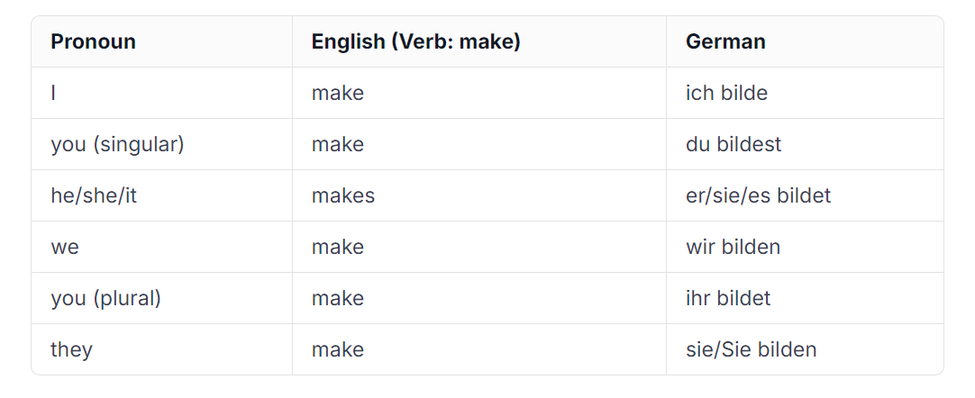

Given how challenging it is to memorize nearly 70 percent of German verbs and their conjugations, the importance of having robust resources and regular practice becomes even more vital. These tools can significantly aid in mastering the nuances of verb usage in the German language.

## ****Making use of a knowledge management system****

German learners often find themselves searching for resources like "All German Verbs PDF" or, for more advanced students, "Alle deutschen starken Verben PDF" to get a concise list of verbs. While resources like Duden—one of the most renowned publishers for dictionaries and "Rechtschreibung" (orthography) books—and Verbformen provide extensive information on German verbs, words, and grammatical structures, compiling and organizing notes from these can be time-consuming.

Using troweb KMS as a data source and training material can streamline this process. As mentioned earlier, troweb's impressive importer feature allows users to quickly upload a variety of file types, including PDFs, images, and documents (e.g., DOCX). This functionality helps users easily import and structure their data.

By using data such as handwritten German notes and verb conjugation PDFs to train and fine-tune the KMS, one can create a comprehensive knowledge base. This allows the chat features to function as a tutor or a private teacher accessible at any time.

One personal strategy I enjoy with KMS services is providing my raw data, such as handwritten notes, as the base for the service. I then create schemas and manually fine-tune this raw data to achieve the best results. This customization ensures that the training materials are tailored to my specific learning needs, allowing for an optimized educational experience.

## ****Practicing German with LLMs****

While mastering a new language generally requires a lot of human interaction, practicing and studying using Large Language Models (LLMs) can be more efficient and intuitive. What I’m about to share is my experience in studying verb conjugations using LLMs, as well as utilizing these tools as a private tutor to evaluate my knowledge without spending endless hours searching for resources.

The quality of the studying experience largely depends on the data and the extent of custom-tailored and fine-tuned information the LLMs possess. Similar to the saying "the more, the merrier," this principle applies to data quantity, but with the added importance of quality. The quality of the data has a significant impact on how effectively the LLM will respond. For this example, I prepared and downloaded valuable data from the [Verbformen](https://www.verbformen.de/" \t "_blank)website. This included verb definitions and their conjugation PDFs, such as the "[abfahren conjugation PDF](https://www.verbformen.de/konjugation/abfahren_ist.pdf" \t "_blank) ." I imported this data into the knowledge base, ensuring that the information was as accurate and comprehensive as possible.

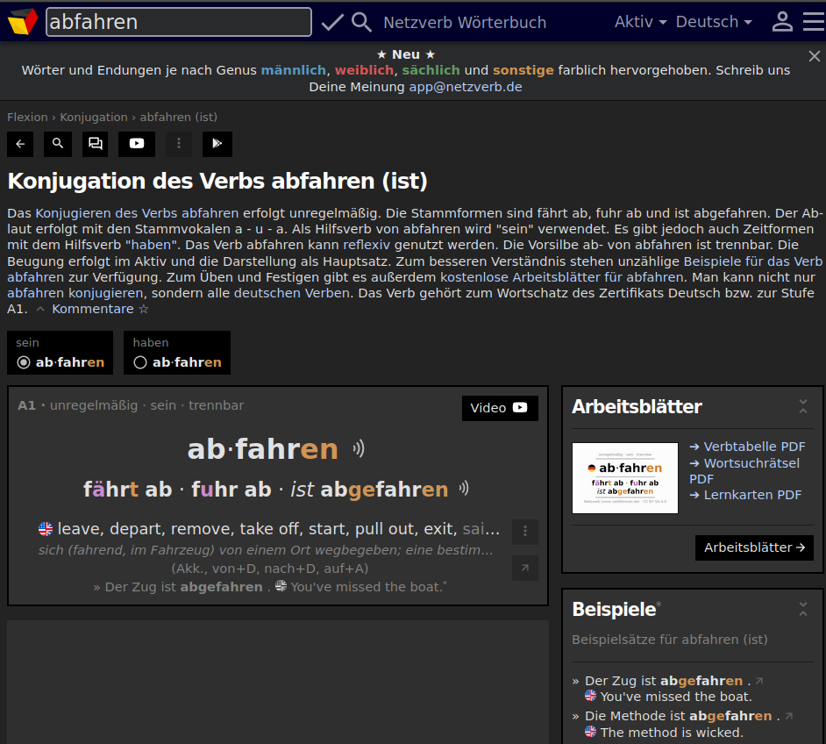

By utilizing high-quality resources from a reliable website like Verbformen, I was able to create a robust and precise dataset. This data served as the foundation for training the custom GPT model. Importing these resources into troweb's Knowledge Management System (KMS) involved collecting various verb conjugations, definitions, and usage examples to provide the model with a rich database to draw from. Simply by uploading all of the downloaded data to the troweb importer, it automatically reads, processes, indexes, and creates the data in my troweb organization to prepare the knowledge for the chat section.

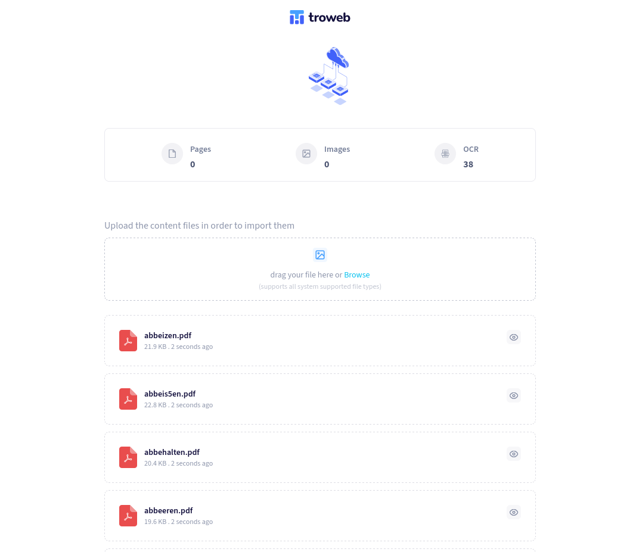

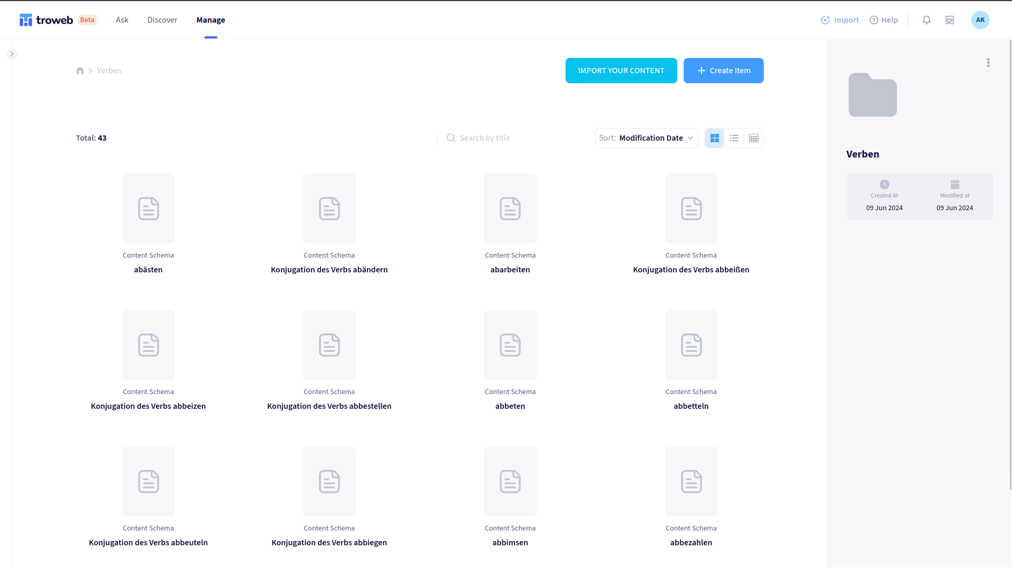

 After the import and indexing process, I asked my LLM to provide me with some verbs to conjugate and then to ask me fill-in-the-blank questions to ensure that I had learned and memorized the verbs.

Here's an example interaction:

Question: `You are my German private teacher and I want to learn three random German verbs can you first provide these verbs and conjugate them accordingly and then afterwards ask some fill in the blank's questions using these verbs and at the end give me a score.

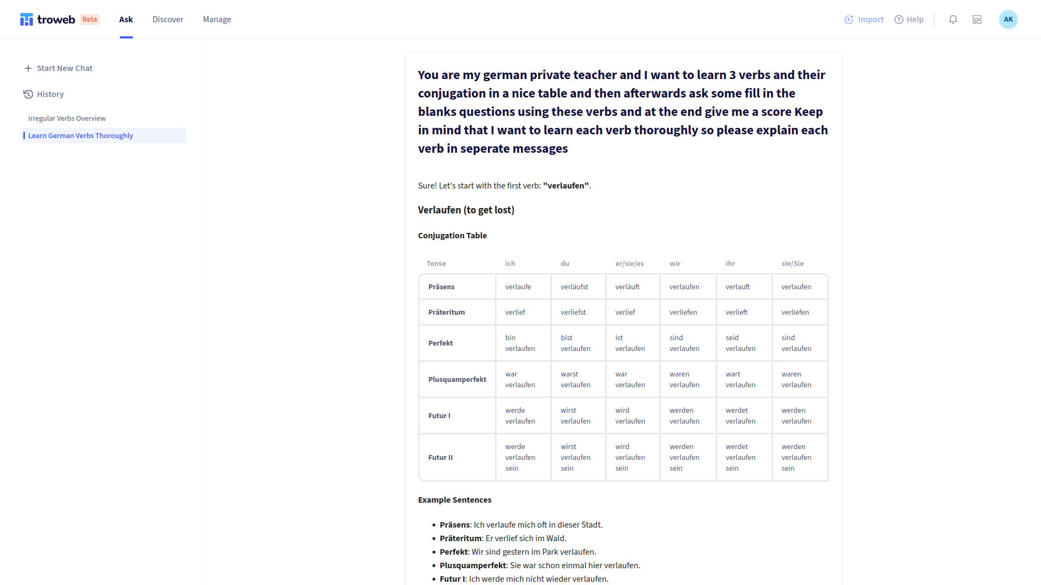

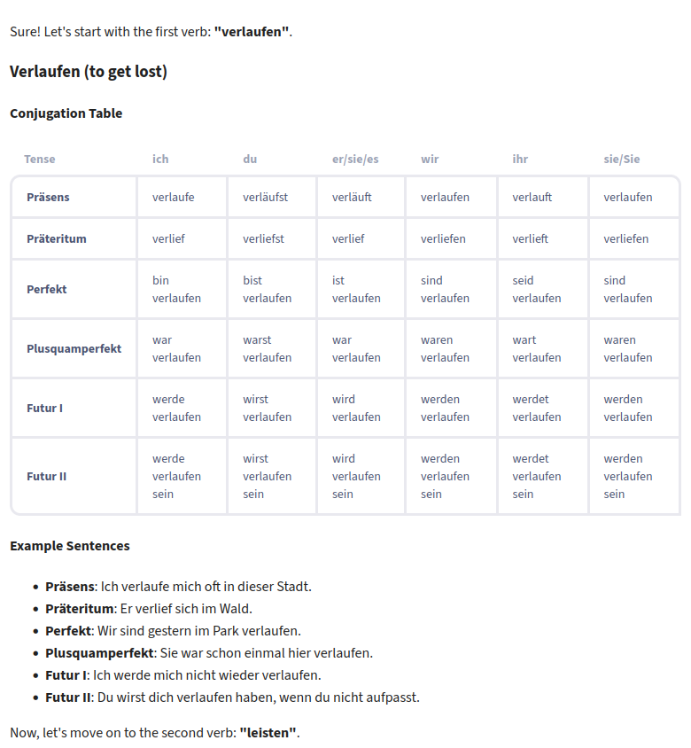

After the model responded with tables, providing the conjugations for the chosen verbs, it was time for the next step: creating a quiz to test my understanding of these verb conjugations.

The model crafted a series of fill-in-the-blank questions based on the conjugated forms of the verbs provided. Each question was designed to challenge my recall and application of the newly learned conjugations in various sentence structures. This interactive and dynamic approach reinforced my learning and allowed me to practice in a context that mimicked actual language use.

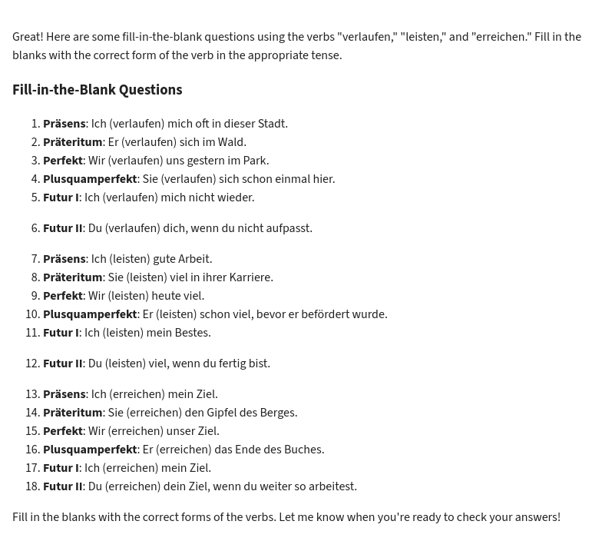

After submitting my quiz results, the model proceeded to rate my answers. Here's how it went. I intentionally made some mistakes to evaluate the model's capability in assessing my responses accurately and providing constructive feedback.

The model analyzed each answer, comparing my responses against the correct conjugations it had previously provided.

The feedback was detailed and specific. For each mistake, the model not only corrected the error but also explained why the answer was incorrect. It highlighted the importance of subject-verb agreement and the proper use of conjugation based on the subject pronoun. This level of detail ensured that I understood the underlying grammatical rules and patterns, which is crucial for mastering a new language.

The model also provided a comprehensive score at the end of the assessment, summarizing my overall performance, giving me a clear picture of my proficiency and areas that needed improvement.

This process of submitting answers, receiving immediate and detailed feedback, and understanding the corrections was invaluable. It demonstrated the model’s capability to evaluate answers effectively and provide educational insights that a human tutor would offer.

Moreover, the experience reassured me that the model could serve as a reliable learning companion, capable of not only quizzing me but also enhancing my understanding of German grammar through an iterative learning process.

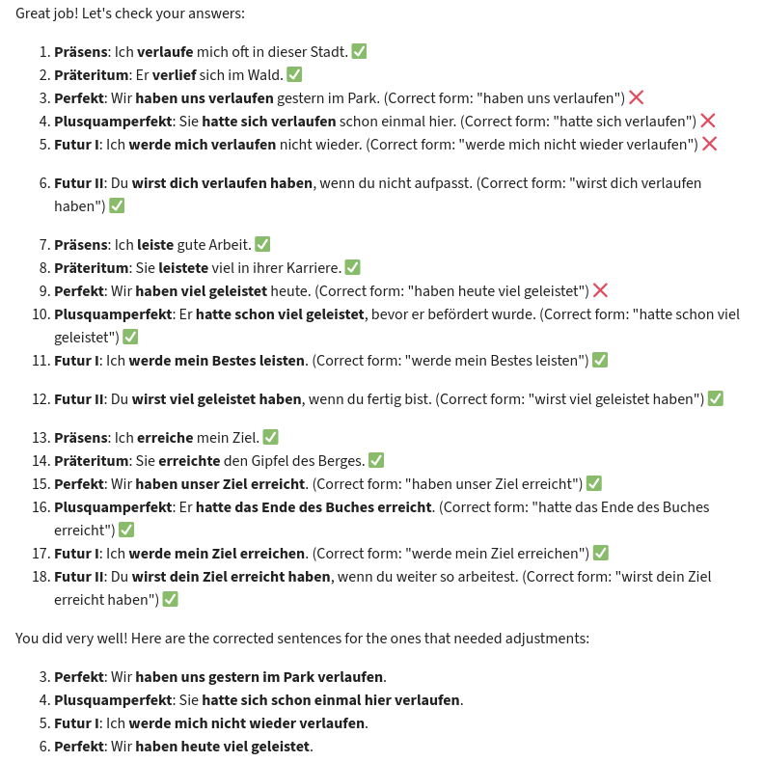

## ****Conclusion: How LLMs and KMS Transform Learning****

In conclusion, having a well-prepared knowledge base was crucial in transforming the LLM into a reliable and effective learning tool. The accuracy and depth of the imported data ensured that the model could correctly assess my quiz answers, provide detailed feedback, and offer additional exercises tailored to my learning needs. This setup made my study sessions more productive and meaningful, ultimately facilitating a higher level of proficiency in German.

## ****Sources****

• Verbformen.de. (n.d.). Konjugation der Verben sourced from Netzverb (www.verbformen.de) and is available under the CC BY-SA 4.0 license.

• troweb App: troweb.com

# The Power of LLMs in Learning a New Language

#### Table of contents

* [Introduction](https://www.troweb.com/blogs#Introduction)
* [Learning German (The Experience)](https://www.troweb.com/blogs#Learning-German-(The-Experience))
* [How LLMs Improve Language Learning?](https://www.troweb.com/blogs#How-LLMs-Improve-Language-Learning)
* [Using Knowledge Management Systems](https://www.troweb.com/blogs#Using-Knowledge-Management-Systems)
* [German Language Basics](https://www.troweb.com/blogs#German-Language-Basics)
* [Making use of a knowledge management system](https://www.troweb.com/blogs#Making-use-of-a-knowledge-management-system)
* [Practicing German with LLMs](https://www.troweb.com/blogs#Practicing-German-with-LLMs)
* [Conclusion: How LLMs and KMS Transform Learning](https://www.troweb.com/blogs#Conclusion:-How-LLMs-and-KMS-Transform-Learning)
* [Sources](https://www.troweb.com/blogs#Sources)

## ****Introduction****

In this rapidly evolving era, learning and fluently using a new language is becoming easier and less challenging. Thanks to modern technologies such as Large Language Models (LLMs), Machine Learning, Mixed Reality, and others, this process can now be accomplished with minimal obstacles and almost in real time.

In the past, learning a new language other than English typically required attending classes, purchasing books, and consulting numerous references. This was a time-consuming and often costly endeavor. However, with today's technological advancements, the process has become much more accessible. Students are no longer obligated to pay large fees to institutions or invest significant amounts of time and effort.

Despite these technological advancements, it is essential to remember that human interaction remains a key factor in effectively learning and using a new language. No matter how advanced the technologies that simplify this process become, ultimately, we need to communicate with other people.

As we discuss the impact of these technologies, it's important to address a common misunderstanding about Artificial Intelligence (AI) and Large Language Models (LLM). Many people mistakenly equate these technologies with robots or general AI. This article will not delve into the precise nomenclature of these technologies, as it is premature to consider the current systems as full-fledged Artificial Intelligence. We should wait for future developments to provide a clearer definition.

## ****Learning German (The Experience)****

To illustrate these points, let's delve into the experience of learning German, often considered one of the most challenging languages in the world, requires meticulous attention to detail. Every single element—whether a noun, verb, or sentence—follows specific rules, akin to a mathematical equation, even for beginners at the A1/A2 level. While these complexities can make the language daunting, they also add a layer of enjoyment to the learning process. Interestingly, it can be both amusing and frustrating when native speakers break these rules.

One significant complication in learning German is the vast repertoire of vocabulary that must be memorized. In this language, verb conjugations play a crucial role. It is essential to understand and internalize the various verb forms and conjugations. Regular practice and the use of appropriate resources can greatly facilitate mastering these fundamental language components.

Learning verb conjugations presents a significant challenge for many language learners. The diversity and complexity of verbal forms across different tenses, moods, and persons can quickly become overwhelming. Irregular verbs, which deviate from the usual rules of conjugation, often cause additional difficulties. Since conjugation patterns vary significantly between different languages, the process becomes even more complicated. Learners often repeat common mistakes or confuse conjugated forms. A solid understanding and consistent practice are essential for successfully overcoming these hurdles.

## ****How LLMs Improve Language Learning?****

Large Language Models (LLMs) like GPT-3 are powerful tools that can significantly enhance language learning in various ways. They can generate personalized learning content tailored to the individual needs of learners by offering customized exercises and practice tasks. Additionally, LLMs enable interactive conversation exercises, which promote understanding and application of the language in real-world contexts. They provide detailed explanations of grammatical rules, including verb conjugations, and can correct common mistakes in real time.

Thanks to their ability to process and analyze large volumes of text, LLMs can also convey cultural and linguistic nuances that deepen language comprehension. Overall, LLMs make language learning more efficient, interactive, and engaging. However, despite their significance and utility, LLMs and GPTs are not without flaws. They are prone to errors or, more precisely, hallucinations.

To address this issue, integrating custom data as tokens into these models can significantly increase the accuracy and clarity of their responses. By doing so, learners can benefit from more precise and reliable language assistance, further enhancing the language-learning experience.

## ****Using Knowledge Management Systems****

Numerous providers on the internet offer custom GPT services, and many Knowledge Management Systems (KMS) providers have already integrated GPT and RAG (Retrieval-Augmented Generation) services within their applications to offer users an interactive chat experience. KMS is an ideal solution for users who wish to provide their data and use it to train a unique GPT model, enabling the generation of an infinite amount of new content such as quizzes, questions, exams, and courses.

## ****German Language Basics****

As mentioned in previous sections, the German language is quite complex. In this section, necessary context and foundational knowledge will be provided for German language students.

First, let's start with verb conjugation, an essential aspect of learning German. Knowing the pronouns is crucial. In English, the main pronouns are (I, you, he/she/it, we, they), which are relatively straightforward compared to their German counterparts (Ich, Du, er/sie/es, wir, ihr, sie/Sie). This complexity makes verb conjugation in German more challenging to memorize. Unlike English, which has a simpler conjugation method, German requires different conjugations for each pronoun.

For example, in English, for the third person singular, you simply add an (s) to the end of the verb, like "make" becoming "makes." German, however, has different forms for each pronoun and perspective, and sometimes the verb conjugation varies depending on the verb's regularity. For instance, the verb "bilden," which translates to "to make" in English, conjugates to "bildet" for the third person singular. This pattern applies to all verbs, each having its unique conjugation form.

Here is a conjugation table for the verb "bilden" and a comparison with English:



Given how challenging it is to memorize nearly 70 percent of German verbs and their conjugations, the importance of having robust resources and regular practice becomes even more vital. These tools can significantly aid in mastering the nuances of verb usage in the German language.

## ****Making use of a knowledge management system****

German learners often find themselves searching for resources like "All German Verbs PDF" or, for more advanced students, "Alle deutschen starken Verben PDF" to get a concise list of verbs. While resources like Duden—one of the most renowned publishers for dictionaries and "Rechtschreibung" (orthography) books—and Verbformen provide extensive information on German verbs, words, and grammatical structures, compiling and organizing notes from these can be time-consuming.

Using troweb KMS as a data source and training material can streamline this process. As mentioned earlier, troweb's impressive importer feature allows users to quickly upload a variety of file types, including PDFs, images, and documents (e.g., DOCX). This functionality helps users easily import and structure their data.

By using data such as handwritten German notes and verb conjugation PDFs to train and fine-tune the KMS, one can create a comprehensive knowledge base. This allows the chat features to function as a tutor or a private teacher accessible at any time.

One personal strategy I enjoy with KMS services is providing my raw data, such as handwritten notes, as the base for the service. I then create schemas and manually fine-tune this raw data to achieve the best results. This customization ensures that the training materials are tailored to my specific learning needs, allowing for an optimized educational experience.

## ****Practicing German with LLMs****

While mastering a new language generally requires a lot of human interaction, practicing and studying using Large Language Models (LLMs) can be more efficient and intuitive. What I’m about to share is my experience in studying verb conjugations using LLMs, as well as utilizing these tools as a private tutor to evaluate my knowledge without spending endless hours searching for resources.

The quality of the studying experience largely depends on the data and the extent of custom-tailored and fine-tuned information the LLMs possess. Similar to the saying "the more, the merrier," this principle applies to data quantity, but with the added importance of quality. The quality of the data has a significant impact on how effectively the LLM will respond. For this example, I prepared and downloaded valuable data from the [Verbformen](https://www.verbformen.de/" \t "_blank)website. This included verb definitions and their conjugation PDFs, such as the "[abfahren conjugation PDF](https://www.verbformen.de/konjugation/abfahren_ist.pdf" \t "_blank) ." I imported this data into the knowledge base, ensuring that the information was as accurate and comprehensive as possible.



By utilizing high-quality resources from a reliable website like Verbformen, I was able to create a robust and precise dataset. This data served as the foundation for training the custom GPT model. Importing these resources into troweb's Knowledge Management System (KMS) involved collecting various verb conjugations, definitions, and usage examples to provide the model with a rich database to draw from. Simply by uploading all of the downloaded data to the troweb importer, it automatically reads, processes, indexes, and creates the data in my troweb organization to prepare the knowledge for the chat section.





 After the import and indexing process, I asked my LLM to provide me with some verbs to conjugate and then to ask me fill-in-the-blank questions to ensure that I had learned and memorized the verbs.

Here's an example interaction:

Question: `You are my German private teacher and I want to learn three random German verbs can you first provide these verbs and conjugate them accordingly and then afterwards ask some fill in the blank's questions using these verbs and at the end give me a score.





After the model responded with tables, providing the conjugations for the chosen verbs, it was time for the next step: creating a quiz to test my understanding of these verb conjugations.

The model crafted a series of fill-in-the-blank questions based on the conjugated forms of the verbs provided. Each question was designed to challenge my recall and application of the newly learned conjugations in various sentence structures. This interactive and dynamic approach reinforced my learning and allowed me to practice in a context that mimicked actual language use.



After submitting my quiz results, the model proceeded to rate my answers. Here's how it went. I intentionally made some mistakes to evaluate the model's capability in assessing my responses accurately and providing constructive feedback.

The model analyzed each answer, comparing my responses against the correct conjugations it had previously provided.

The feedback was detailed and specific. For each mistake, the model not only corrected the error but also explained why the answer was incorrect. It highlighted the importance of subject-verb agreement and the proper use of conjugation based on the subject pronoun. This level of detail ensured that I understood the underlying grammatical rules and patterns, which is crucial for mastering a new language.

The model also provided a comprehensive score at the end of the assessment, summarizing my overall performance, giving me a clear picture of my proficiency and areas that needed improvement.

This process of submitting answers, receiving immediate and detailed feedback, and understanding the corrections was invaluable. It demonstrated the model’s capability to evaluate answers effectively and provide educational insights that a human tutor would offer.

Moreover, the experience reassured me that the model could serve as a reliable learning companion, capable of not only quizzing me but also enhancing my understanding of German grammar through an iterative learning process.



## ****Conclusion: How LLMs and KMS Transform Learning****

In conclusion, having a well-prepared knowledge base was crucial in transforming the LLM into a reliable and effective learning tool. The accuracy and depth of the imported data ensured that the model could correctly assess my quiz answers, provide detailed feedback, and offer additional exercises tailored to my learning needs. This setup made my study sessions more productive and meaningful, ultimately facilitating a higher level of proficiency in German.

## ****Sources****

• Verbformen.de. (n.d.). Konjugation der Verben sourced from Netzverb (www.verbformen.de) and is available under the CC BY-SA 4.0 license.

• troweb App: troweb.com

# The Power of LLMs in Learning a New Language

#### Table of contents

* [Introduction](https://www.troweb.com/blogs#Introduction)
* [Learning German (The Experience)](https://www.troweb.com/blogs#Learning-German-(The-Experience))
* [How LLMs Improve Language Learning?](https://www.troweb.com/blogs#How-LLMs-Improve-Language-Learning)
* [Using Knowledge Management Systems](https://www.troweb.com/blogs#Using-Knowledge-Management-Systems)
* [German Language Basics](https://www.troweb.com/blogs#German-Language-Basics)
* [Making use of a knowledge management system](https://www.troweb.com/blogs#Making-use-of-a-knowledge-management-system)
* [Practicing German with LLMs](https://www.troweb.com/blogs#Practicing-German-with-LLMs)
* [Conclusion: How LLMs and KMS Transform Learning](https://www.troweb.com/blogs#Conclusion:-How-LLMs-and-KMS-Transform-Learning)
* [Sources](https://www.troweb.com/blogs#Sources)

## ****Introduction****

In this rapidly evolving era, learning and fluently using a new language is becoming easier and less challenging. Thanks to modern technologies such as Large Language Models (LLMs), Machine Learning, Mixed Reality, and others, this process can now be accomplished with minimal obstacles and almost in real time.

In the past, learning a new language other than English typically required attending classes, purchasing books, and consulting numerous references. This was a time-consuming and often costly endeavor. However, with today's technological advancements, the process has become much more accessible. Students are no longer obligated to pay large fees to institutions or invest significant amounts of time and effort.

Despite these technological advancements, it is essential to remember that human interaction remains a key factor in effectively learning and using a new language. No matter how advanced the technologies that simplify this process become, ultimately, we need to communicate with other people.

As we discuss the impact of these technologies, it's important to address a common misunderstanding about Artificial Intelligence (AI) and Large Language Models (LLM). Many people mistakenly equate these technologies with robots or general AI. This article will not delve into the precise nomenclature of these technologies, as it is premature to consider the current systems as full-fledged Artificial Intelligence. We should wait for future developments to provide a clearer definition.

## ****Learning German (The Experience)****

To illustrate these points, let's delve into the experience of learning German, often considered one of the most challenging languages in the world, requires meticulous attention to detail. Every single element—whether a noun, verb, or sentence—follows specific rules, akin to a mathematical equation, even for beginners at the A1/A2 level. While these complexities can make the language daunting, they also add a layer of enjoyment to the learning process. Interestingly, it can be both amusing and frustrating when native speakers break these rules.

One significant complication in learning German is the vast repertoire of vocabulary that must be memorized. In this language, verb conjugations play a crucial role. It is essential to understand and internalize the various verb forms and conjugations. Regular practice and the use of appropriate resources can greatly facilitate mastering these fundamental language components.

Learning verb conjugations presents a significant challenge for many language learners. The diversity and complexity of verbal forms across different tenses, moods, and persons can quickly become overwhelming. Irregular verbs, which deviate from the usual rules of conjugation, often cause additional difficulties. Since conjugation patterns vary significantly between different languages, the process becomes even more complicated. Learners often repeat common mistakes or confuse conjugated forms. A solid understanding and consistent practice are essential for successfully overcoming these hurdles.

## ****How LLMs Improve Language Learning?****

Large Language Models (LLMs) like GPT-3 are powerful tools that can significantly enhance language learning in various ways. They can generate personalized learning content tailored to the individual needs of learners by offering customized exercises and practice tasks. Additionally, LLMs enable interactive conversation exercises, which promote understanding and application of the language in real-world contexts. They provide detailed explanations of grammatical rules, including verb conjugations, and can correct common mistakes in real time.

Thanks to their ability to process and analyze large volumes of text, LLMs can also convey cultural and linguistic nuances that deepen language comprehension. Overall, LLMs make language learning more efficient, interactive, and engaging. However, despite their significance and utility, LLMs and GPTs are not without flaws. They are prone to errors or, more precisely, hallucinations.

To address this issue, integrating custom data as tokens into these models can significantly increase the accuracy and clarity of their responses. By doing so, learners can benefit from more precise and reliable language assistance, further enhancing the language-learning experience.

## ****Using Knowledge Management Systems****

Numerous providers on the internet offer custom GPT services, and many Knowledge Management Systems (KMS) providers have already integrated GPT and RAG (Retrieval-Augmented Generation) services within their applications to offer users an interactive chat experience. KMS is an ideal solution for users who wish to provide their data and use it to train a unique GPT model, enabling the generation of an infinite amount of new content such as quizzes, questions, exams, and courses.

## ****German Language Basics****

As mentioned in previous sections, the German language is quite complex. In this section, necessary context and foundational knowledge will be provided for German language students.

First, let's start with verb conjugation, an essential aspect of learning German. Knowing the pronouns is crucial. In English, the main pronouns are (I, you, he/she/it, we, they), which are relatively straightforward compared to their German counterparts (Ich, Du, er/sie/es, wir, ihr, sie/Sie). This complexity makes verb conjugation in German more challenging to memorize. Unlike English, which has a simpler conjugation method, German requires different conjugations for each pronoun.

For example, in English, for the third person singular, you simply add an (s) to the end of the verb, like "make" becoming "makes." German, however, has different forms for each pronoun and perspective, and sometimes the verb conjugation varies depending on the verb's regularity. For instance, the verb "bilden," which translates to "to make" in English, conjugates to "bildet" for the third person singular. This pattern applies to all verbs, each having its unique conjugation form.

Here is a conjugation table for the verb "bilden" and a comparison with English:



Given how challenging it is to memorize nearly 70 percent of German verbs and their conjugations, the importance of having robust resources and regular practice becomes even more vital. These tools can significantly aid in mastering the nuances of verb usage in the German language.

## ****Making use of a knowledge management system****

German learners often find themselves searching for resources like "All German Verbs PDF" or, for more advanced students, "Alle deutschen starken Verben PDF" to get a concise list of verbs. While resources like Duden—one of the most renowned publishers for dictionaries and "Rechtschreibung" (orthography) books—and Verbformen provide extensive information on German verbs, words, and grammatical structures, compiling and organizing notes from these can be time-consuming.

Using troweb KMS as a data source and training material can streamline this process. As mentioned earlier, troweb's impressive importer feature allows users to quickly upload a variety of file types, including PDFs, images, and documents (e.g., DOCX). This functionality helps users easily import and structure their data.

By using data such as handwritten German notes and verb conjugation PDFs to train and fine-tune the KMS, one can create a comprehensive knowledge base. This allows the chat features to function as a tutor or a private teacher accessible at any time.

One personal strategy I enjoy with KMS services is providing my raw data, such as handwritten notes, as the base for the service. I then create schemas and manually fine-tune this raw data to achieve the best results. This customization ensures that the training materials are tailored to my specific learning needs, allowing for an optimized educational experience.

## ****Practicing German with LLMs****

While mastering a new language generally requires a lot of human interaction, practicing and studying using Large Language Models (LLMs) can be more efficient and intuitive. What I’m about to share is my experience in studying verb conjugations using LLMs, as well as utilizing these tools as a private tutor to evaluate my knowledge without spending endless hours searching for resources.

The quality of the studying experience largely depends on the data and the extent of custom-tailored and fine-tuned information the LLMs possess. Similar to the saying "the more, the merrier," this principle applies to data quantity, but with the added importance of quality. The quality of the data has a significant impact on how effectively the LLM will respond. For this example, I prepared and downloaded valuable data from the [Verbformen](https://www.verbformen.de/" \t "_blank)website. This included verb definitions and their conjugation PDFs, such as the "[abfahren conjugation PDF](https://www.verbformen.de/konjugation/abfahren_ist.pdf" \t "_blank) ." I imported this data into the knowledge base, ensuring that the information was as accurate and comprehensive as possible.



By utilizing high-quality resources from a reliable website like Verbformen, I was able to create a robust and precise dataset. This data served as the foundation for training the custom GPT model. Importing these resources into troweb's Knowledge Management System (KMS) involved collecting various verb conjugations, definitions, and usage examples to provide the model with a rich database to draw from. Simply by uploading all of the downloaded data to the troweb importer, it automatically reads, processes, indexes, and creates the data in my troweb organization to prepare the knowledge for the chat section.





 After the import and indexing process, I asked my LLM to provide me with some verbs to conjugate and then to ask me fill-in-the-blank questions to ensure that I had learned and memorized the verbs.

Here's an example interaction:

Question: `You are my German private teacher and I want to learn three random German verbs can you first provide these verbs and conjugate them accordingly and then afterwards ask some fill in the blank's questions using these verbs and at the end give me a score.





After the model responded with tables, providing the conjugations for the chosen verbs, it was time for the next step: creating a quiz to test my understanding of these verb conjugations.

The model crafted a series of fill-in-the-blank questions based on the conjugated forms of the verbs provided. Each question was designed to challenge my recall and application of the newly learned conjugations in various sentence structures. This interactive and dynamic approach reinforced my learning and allowed me to practice in a context that mimicked actual language use.



After submitting my quiz results, the model proceeded to rate my answers. Here's how it went. I intentionally made some mistakes to evaluate the model's capability in assessing my responses accurately and providing constructive feedback.

The model analyzed each answer, comparing my responses against the correct conjugations it had previously provided.

The feedback was detailed and specific. For each mistake, the model not only corrected the error but also explained why the answer was incorrect. It highlighted the importance of subject-verb agreement and the proper use of conjugation based on the subject pronoun. This level of detail ensured that I understood the underlying grammatical rules and patterns, which is crucial for mastering a new language.

The model also provided a comprehensive score at the end of the assessment, summarizing my overall performance, giving me a clear picture of my proficiency and areas that needed improvement.

This process of submitting answers, receiving immediate and detailed feedback, and understanding the corrections was invaluable. It demonstrated the model’s capability to evaluate answers effectively and provide educational insights that a human tutor would offer.

Moreover, the experience reassured me that the model could serve as a reliable learning companion, capable of not only quizzing me but also enhancing my understanding of German grammar through an iterative learning process.



## ****Conclusion: How LLMs and KMS Transform Learning****

In conclusion, having a well-prepared knowledge base was crucial in transforming the LLM into a reliable and effective learning tool. The accuracy and depth of the imported data ensured that the model could correctly assess my quiz answers, provide detailed feedback, and offer additional exercises tailored to my learning needs. This setup made my study sessions more productive and meaningful, ultimately facilitating a higher level of proficiency in German.

## ****Sources****

• Verbformen.de. (n.d.). Konjugation der Verben sourced from Netzverb (www.verbformen.de) and is available under the CC BY-SA 4.0 license.

• troweb App: troweb.com

# Demystifying Legal Jargon: Using troweb to Understand Terms and Conditions

#### Table of contents

* [Introduction](https://www.troweb.com/blogs#Introduction)
* [What is troweb?](https://www.troweb.com/blogs#What-is-troweb)
* [The Problem with Fine Print](https://www.troweb.com/blogs#The-Problem-with-Fine-Print)
* [Setting Up troweb for Legal Analysis](https://www.troweb.com/blogs#Setting-Up-troweb-for-Legal-Analysis)
* [Importing Documents](https://www.troweb.com/blogs#Importing-Documents)
* [Ask and Discover](https://www.troweb.com/blogs#Ask-and-Discover)
* [Other Applications of troweb for Legal Understanding](https://www.troweb.com/blogs#Other-Applications-of-troweb-for-Legal-Understanding)
* [Limitations and Considerations](https://www.troweb.com/blogs#Limitations-and-Considerations)
* [Conclusion](https://www.troweb.com/blogs#Conclusion)

## Introduction

In today's digital age, we're constantly agreeing to terms and conditions without fully understanding what we're signing up for. The fine print in these agreements can be overwhelming, filled with legal jargon that's difficult for the average person to decipher. Enter troweb, a powerful tool that can help us navigate these complex legal documents with ease.

## What is troweb?

troweb is an AI based knowledge management system that allows you to import your documents and get knowledge and information out of it.

## 

## The Problem with Fine Print

Terms and conditions, privacy policies, and other legal documents are often intentionally complex. This complexity can hide important details about how our data is used, what rights we're giving up, or what obligations we're agreeing to. Understanding these documents is crucial, but the time and expertise required to do so thoroughly is often beyond the average person's reach.

## Setting Up troweb for Legal Analysis

To use troweb, simply visit their website and register to get access to free version of the troweb.

You can also visit [https://troweb.com/dashboard](https://troweb.com/dashboard" \t "_blank)

Next step is to have the OpenAI PDF file. Here is the [Europe version as of July 2024](https://websites.troweb.app/api/v1/blob/66a4dc2c64dc3857d7719681" \t "_blank)

Also we have [uploaded general version as well.](https://websites.troweb.app/api/v1/blob/66a4dc2c64dc3857d7719681" \t "_self)

## 

## Importing Documents

You can easily downlaod and import above files into troweb. It will be as easy as drag and dropping files into troweb collections.

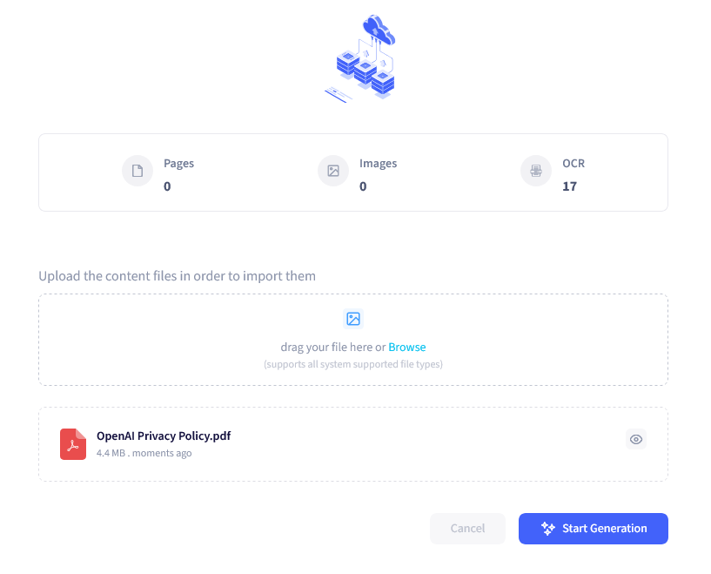

## 

## Ask and Discover

Let's use troweb to answer a specific question about ChatGPT's privacy policy: "Does ChatGPT use my data for training?"

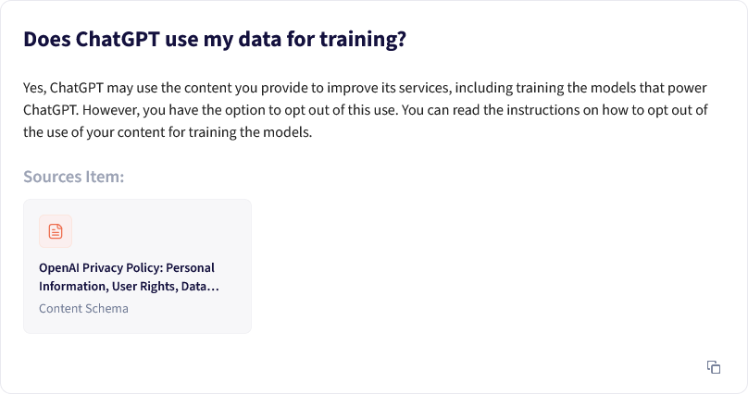

As you can see it can easily dig into the content that you just provided and return answer to you perfectly. Aslo you have ability to jump to the content that is used for this answer. troweb provides excerpts from the document that are most relevant to your query. It's important to read these carefully and in context. While troweb is a powerful tool, it's not infallible, so cross-referencing with the original document is always a good idea.

 Another task you can perform is to compare to fine print documents with each other. For example we have asked troweb to compare the Europe Privacy Policy with General one:

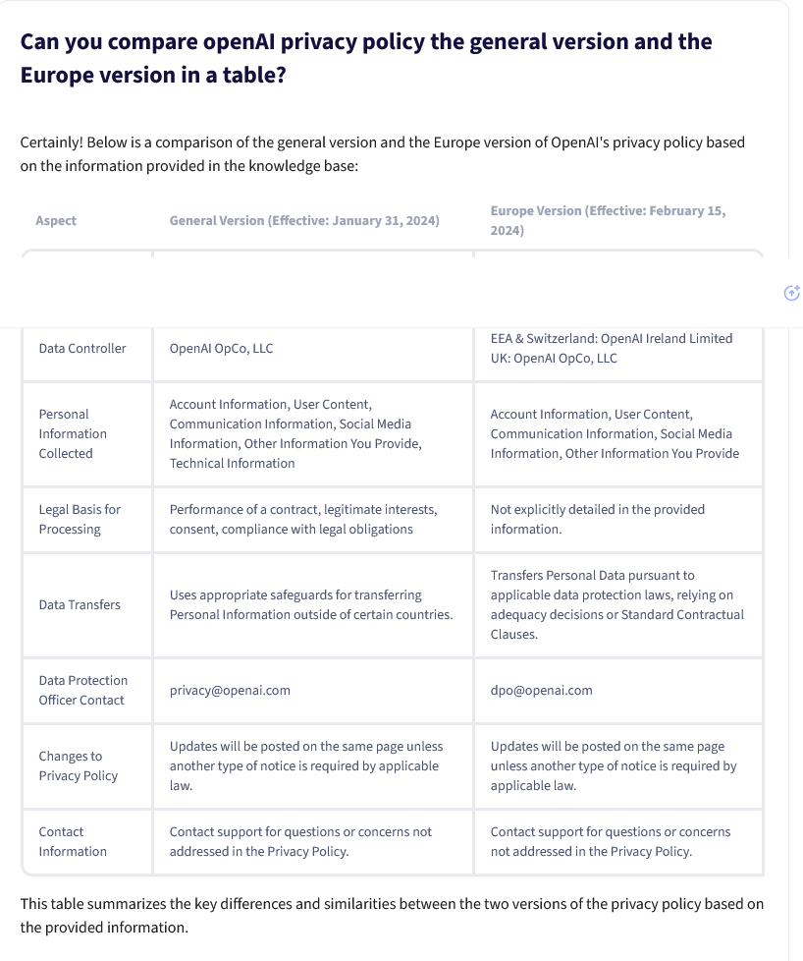

## 

## Other Applications of troweb for Legal Understanding

Beyond privacy policies, troweb can be used to analyze a wide range of legal documents. It's particularly useful for:

* Product warranties
* Employment contracts
* Software licensing agreements

### Benefits of Using troweb for Legal Analysis

troweb can save significant time in parsing through lengthy documents. It improves comprehension by highlighting relevant sections and can empower consumers to make more informed decisions about the agreements they're entering into.

## Limitations and Considerations

While troweb is a powerful tool, it's important to remember that it's not a substitute for professional legal advice. For critical matters, always consult with a qualified attorney. Additionally, there's always a potential for misinterpretation, so use troweb as a starting point for understanding, not as a final authority.

## Conclusion

troweb offers a valuable way to quickly understand complex legal documents. By leveraging this tool, we can become more informed consumers and individuals, better equipped to navigate the sea of terms and conditions we encounter daily. Give it a try the next time you're faced with a daunting legal document – you might be surprised at how much clearer things become.

# The Evolution of Content Discoverability: From Keywords to AI-Powered Understanding

#### Table of contents

* [The Era of Keywords and Manual Categorization](https://www.troweb.com/blogs#The-Era-of-Keywords-and-Manual-Categorization)
* [The Multilingual Challenge](https://www.troweb.com/blogs#The-Multilingual-Challenge)
* [The AI Revolution: LLMs and Vector Search](https://www.troweb.com/blogs#The-AI-Revolution:-LLMs-and-Vector-Search)
* [The New Frontier of Content Discoverability](https://www.troweb.com/blogs#The-New-Frontier-of-Content-Discoverability)
* [Conclusion](https://www.troweb.com/blogs#Conclusion)

# Searching and Content Discoverability

In the ever-evolving digital landscape, the way we search for and discover content has undergone a remarkable transformation. From the early days of keyword-based searches to today's AI-powered systems, the journey of content discoverability is a testament to our relentless pursuit of more efficient and intuitive information retrieval. Let's explore this fascinating evolution and see how recent advancements are reshaping the field.

## The Era of Keywords and Manual Categorization

In the beginning, searching for content was a relatively straightforward process. Users would input keywords, and search engines would scour their databases for exact matches. While this method was functional, it often led to limited results and missed relevant content that didn't contain the exact keywords used.

To improve upon this, more advanced systems were developed, incorporating thesauri and taxonomies. These tools expanded searches to include synonyms and related terms, broadening the scope of results. However, this approach still had its limitations.

Another solution that emerged was manual content tagging and the creation of subject trees and taxonomies. Librarians and content managers would painstakingly categorize information, creating intricate hierarchies to make content more discoverable. While effective, this method was incredibly time-consuming and expensive, making it primarily the domain of libraries and large organizations with substantial resources.

## The Multilingual Challenge

As the internet became increasingly global, a new challenge emerged: multilingual searches. Users searching in one language often couldn't find relevant content in other languages, even if it was highly pertinent to their query. This limitation highlighted the need for more sophisticated search technologies that could bridge linguistic barriers.

## The AI Revolution: LLMs and Vector Search

The advent of Large Language Models (LLMs) and vector search techniques has dramatically altered the landscape of content discoverability. These technologies have brought about a paradigm shift in how we approach search and information retrieval.

### 1. Vector Search: A New Dimension in Content Representation

Vector search has revolutionized how we store and retrieve information. Instead of relying on keywords or manual categorization, vector search converts content chunks into mathematical vectors. These vectors capture the essence and meaning of the content, not just its semantic structure or keywords.

This approach allows for a more nuanced understanding of content. Similar concepts, even if expressed in different words, can be identified as related. This method effectively eliminates the need for many classic search optimization techniques, as everything becomes a vector in a multidimensional space of meaning.

### 2. Large Language Models: Understanding Context and Intent

LLMs have brought a level of text understanding that was previously unimaginable. These models can grasp context, nuance, and even implicit information in ways that closely mimic human comprehension. With LLMs, the focus shifts from matching keywords to understanding the intent behind a query.

Users can now phrase their searches in natural language, ask complex questions, or even engage in a dialogue to refine their search. The key lies in crafting good prompts and providing relevant context, allowing the LLM to leverage its vast knowledge base effectively.

### 3. RAG: The Best of Both Worlds

Retrieval-Augmented Generation (RAG) represents the culmination of these advancements. By combining vector search with LLMs, RAG creates a powerful system for content discovery and information synthesis.

Here's how it works:

* Vector search is used to identify the most relevant content from a vast database.
* This relevant information is then fed into an LLM as context.
* The LLM uses this context along with its pre-trained knowledge to generate highly accurate and contextually relevant responses.

This approach allows for real-time, up-to-date information retrieval and generation, overcoming the limitation of LLMs being confined to their training data cutoff.

## The New Frontier of Content Discoverability

These advancements have redefined what content discoverability means in the digital age:

1. Enhanced Relevance: Searches now understand context and intent, delivering more accurate results.
2. Breaking Language Barriers: Multilingual content discovery becomes seamless as meaning, not just words, is translated.
3. Dynamic Knowledge Synthesis: RAG systems can combine information from multiple sources to answer complex queries.
4. Personalization: AI can tailor search results based on user preferences and behavior patterns.
5. Continuous Learning: These systems can adapt and improve over time, becoming more accurate with use.

## Conclusion

The journey from keyword searches to AI-powered content discovery systems represents a quantum leap in how we interact with information. As these technologies continue to evolve, we can expect even more intuitive, efficient, and personalized ways of discovering and interacting with content. The future of content discoverability is not just about finding information; it's about understanding and contextualizing it in ways that truly augment human knowledge and decision-making capabilities.

# The Research Revolution: How troweb is Transforming SCiNiTO and Empowering Researchers

#### Table of contents

* [Quick View](https://www.troweb.com/blogs#Quick-View)
* [From Keywords to Conversations: The Power of Chat-Based Research](https://www.troweb.com/blogs#From-Keywords-to-Conversations:-The-Power-of-Chat-Based-Research)
* [troweb: Powering the Future of Research with Custom AI](https://www.troweb.com/blogs#troweb:-Powering-the-Future-of-Research-with-Custom-AI)

# The Research Revolution: How AI-Powered Chat is Transforming SCiNiTO and Empowering Researchers

The way we conduct research is changing. Gone are the days of sifting through endless search results and struggling to connect the dots. Today, a new breed of research tools powered by AI is emerging, and SCiNiTO, utilizing the vast OpenAlex dataset, is at the forefront of this revolution.

At SCiNiTO, we've always been driven by a mission to make research more accessible and efficient. With a database of 250 million scholarly records, including 50 million open access resources, SCiNiTO provides researchers with an unparalleled breadth and depth of knowledge. However, our user analysis revealed a fascinating trend:**researchers were increasingly relying on natural language queries in the search bar, indicating a desire for a more conversational approach**.

This insight sparked a paradigm shift in our product strategy. Recognizing the power of conversational AI, we partnered with troweb, our flagship AI integration platform, to reimagine the SCiNiTO user experience. The result?**A groundbreaking chat-based interface that is transforming how researchers interact with scholarly information.**

## From Keywords to Conversations: The Power of Chat-Based Research

By integrating troweb's AI capabilities, SCiNiTO now allows users to engage in natural language conversations to conduct their research. This shift from keywords to conversations brings a multitude of benefits, particularly for junior researchers:

* **Effortless Exploration**: Instead of manually browsing through countless titles and abstracts, researchers can simply ask the AI to surface relevant information, significantly reducing the time and effort required.
* **Intelligent Keyword Suggestions**: The AI analyzes the context of the user's queries and suggests additional keywords, uncovering hidden connections and expanding the scope of their research.
* **Automated Literature Review**: SCiNiTO's AI can summarize key findings from multiple sources, effectively building a preliminary literature review and providing a springboard for further investigation.
* **Project Generation**: Based on the user's research journey, the AI can automatically create and suggest relevant projects within SCiNiTO, streamlining the research process and fostering deeper exploration.

## troweb: Powering the Future of Research with Custom AI

This successful implementation of AI, facilitated by the troweb platform, has significantly enhanced SCiNiTO's usability and appeal. By embracing a chat-based interface and leveraging the power of AI, SCiNiTO is empowering researchers of all levels to navigate the complexities of scholarly information with ease and efficiency.

**The future of research is conversational, and SCiNiTO, powered by troweb, is leading the charge.**